
Risk-to-Economic Dispatch for a Gas Turbine: Conformal Risk Control of NOx, CO and TIT

Supervisor: Dr Jafar Al Zaili Student: Daniel Primero Nkaa Keabou
City St George’s, University of London City St George’s, University of London
Jafar.Akzaili@citystgeorges.ac.uk daniel-primero.nkaa-keabou@city.ac.uk

ABSTRACT

This dissertation develops a risk-managed approach to gas-turbine economic dispatch when the plant model is learned from data and is therefore imperfect. The main challenge is to predict turbine and emissions behaviour, and to use those predictions safely inside an economic optimiser, where small model errors can lead to unsafe operating decisions.

Using an open gas-turbine operating dataset, ML surrogate models are trained to predict turbine performance and emissions outcomes, including NOx and CO, from operating conditions and candidate power settings. To make these models safe enough for dispatch, their predictions are augmented with distribution-free uncertainty buffers using conformal calibration. A conformal risk-control gate is then calibrated on closed-loop rollouts so that the controller can target a chosen rate of constraint exceedance under its own decision-induced distribution shift.

The resulting controller selects hourly operating points by filtering out candidates predicted to be unsafe under the calibrated bounds and risk gate, then maximising a simplified economic objective. The results show that dispatch feasibility and value depend less on average prediction accuracy than on how uncertainty handling reshapes the feasible action set, with turbine inlet temperature (TIT) typically acting as the binding constraint. A risk-tolerance knee around α ≈ 0.10–0.15 emerged, beyond which extra risk gives diminishing value.

It provides a methodology for risk-managed dispatch, along with diagnostic tools to explain when and why dispatch becomes infeasible and how safety and emissions control interact with economic value. The main limitations are simplified economics, simulation noise from residual resampling, and reduced formal validity under time dependence.

Contents
1 INTRODUCTION 5
1.1 Problem Statement 5
1.2 Context 5
1.3 Gap 6
1.4 Aims 6
2 Background and Literature Review 6
2.1 Thermodynamic Foundation 6
2.2 TIT Decision Importance 7
2.3 Pollutant Formation Mechanisms And Temperature Sensitivity For Nox And CO 8
2.4 The Relevant Pollutants and the Public Health 9
2.5 Data Driven Gas Turbine Emissions Modelling 9
2.6 Optimizer-In-The-Loop Approach 10
2.7 Distribution-Free Calibration And Risk Control 10
2.8 Multi-Objective Economic-Emissions Trade Offs 11
3 Methodology 12
3.1 Problem Setup 12
3.1.1 Economic Objective 12
3.1.2 Operational And Safety Constraints 12
3.1.3 Conformal Upper Bounds 13
3.1.4 Controller Optimizer Per Hour 13
3.1.5 Control Of Risk Parameters 13
3.2 Surrogate Model Training 13
3.2.1 Reasoning For Gradient Boosted Trees Over NNs 13
3.2.2 Specific Surrogate Implementation Used 14
3.2.3 Lags And Their Physical Significance In Emission Prediction 15
3.3 Conformal Calibration 15
3.4 CRC Threshold 16
3.5 Closed Loop Simulator 17
3.6 Assumptions, Limitations, Complexity 19
3.6.1 Assumptions 19
3.6.2 Limitations 20
3.6.3 Computational Complexity 20
3.7 Issues encountered 21
3.7.1 Low accuracy model accuracy without considering time dynamics 21
3.7.2 Unfaithful CRC implementation 22
3.7.3 Computation time 23
4 Results And Discussion 24
4.1 Description of Result Set 24
4.2 Key Result 24
4.3 Surrogate Model Point Accuracy 24
4.3.1 Point Model 24
4.3.2 Tail Accuracy And Uncertainty Calibration 25
4.4 Simulation 26
4.4.1 CRC Risk Threshold And Closed Loop Risk Control 26
4.5 Pareto Frontier 28
5 The Wider Context 31
5.1 Interpretation of results 31
5.2 Operational Translation of Variables 31
5.3 Failure Modes And Shortcomings 32
6 Conclusion 33
7 Bibliography 34
8 Appendices 37
8.1 A: Pseudocode summary of main algorithms used in codebase 37
8.2 B – Results Tables 42
8.3 C – Nomenclature for complexity analysis 46
8.4 D – Equation Index 46

Table of figures

Figure 1 - Overall Research Workflow 5
Figure 2 - Physical Links between Gas Turbine operation, TIT, and Emissions risk 7
Figure 3 - CRC and Closed Loop Calibration 17
Figure 4 - Per hour dispatch optimiser 19
Figure 5 - Old CRC Implementation 22
Figure 6 - Improved CRC implementation 22
Figure 7 - CRC Risk Calibration and Closed-Loop Breach Diagnostics 25
Figure 8 - Risk–Cash Frontier Across α Risk Tolerances 26
Figure 9 - Target-Wise Risk to Cash Frontier 27
Figure 10 - CRC risk-budget utilisation across alpha 27
Figure 11 - Realised Breach rates vs target alpha 27
Figure 12 - Shadow Price of risk tolerance 27
Figure 13 - Global alpha-epsilon pareto cloud with non dominated envelope 29
Figure 14 - Feasibility map over alpha - epsilon grid 29
Figure 15 - Money heatmap over alpha-epsilon grid 30
Figure 16 - Emission heatmap over alpha-epsilon grid 30
Figure 17 - Pareto Fronts with knee/baseline/clean markers 30
Figure 18 - Cumulative trade-off at alpha = 0.1 31
Figure 19 - MAC along Pareto frontier at alpha = 0.1 31

INTRODUCTION

Problem Statement
Gas turbine dispatch is difficult because the operating point that gives the most power or profit is not always the one that is safest to run. A turbine may perform well economically at certain settings, but those same settings can cause important limits to be exceeded, especially for turbine inlet temperature, NOx, and CO. This creates a control optimisation problem, because operators must balance economic performance against thermal and emissions constraints at the same time. Machine-learning models can help with this by predicting turbine behaviour much faster than detailed physics-based simulations. However, these models are not perfectly accurate, and prediction errors can lead to unsafe dispatch decisions if they are used without caution. The aim of this dissertation is to develop a turbine dispatch method that uses machine-learning predictions in a safer and more reliable way. It does this by adding calibrated safety margins, so that dispatch decisions can still achieve strong economic performance while reducing the risk of violating temperature and emissions limits.

The overall research story can be encapsulated by the following diagram:

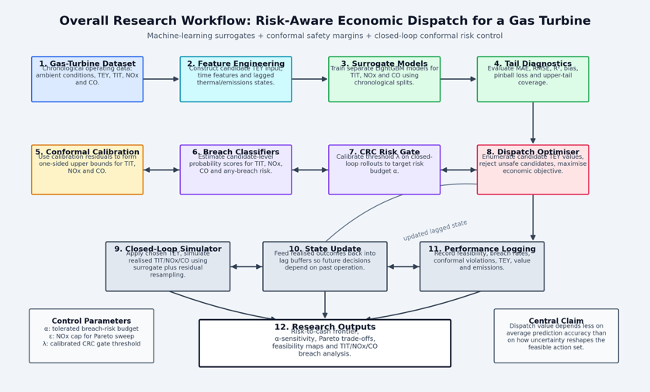
Figure 1 - Overall Research Workflow

Context
Economic dispatch (ED) is an important problem in power systems. When given demand and operating constraints, it allocates generator setpoints to meet load while minimizing operating cost over a dispatch interval. ED is usually posed with engineering constraints such as output limits, ramping and operating envelopes, and re-solved as conditions change. This is an elementary optimization task for reliable, efficient system operation (Marouani et al., 2022).
Environmental constraints add more complexity to operational decision making. Beyond fuel cost, operators often face requirements to limit pollutant emissions, which motivates an approach that combines economics and emissions in dispatch (CEED) that trade off operating cost against emissions. This is commonly represented as a multi objective optimization (Asif et al., 2024).

In this context, gas turbines are particularly relevant because their emissions and thermal states vary strongly with operating points and ambient conditions. The formulation of NOx is closely related to combustion temperature and related thermos-chemical pathways. As such, strategies that reduce peak temperature are important to NOx control in turbines (Richards et al., n.d.). At the same time, CO emissions can be restrictive at lower load operation where combustion completeness is reduced, which creates an operational tension between flexibility, thermal constrains and emissions (Lipperheide et al., 2018). These sort of interactions between mechanisms means that operating points are not
automatically emissions safe, and that decisions during dispatch can meaningfully change pollutant profiles.
Alongside this, there exists advanced predictive emissions monitoring that estimate turbine emissions from routinely measured sensor and ambient signals. Recent studies continue to develop data driven emissions predictors for turbines using datasets (dos Santos Coelho et al., 2024a). Together, ED/CEED formulations provides a system for selecting setpoints under operational constraints, while gas turbine emissions physics and data from monitoring can educated handling of pollutant and thermal outcomes and quantities that are relevant for decision making.

Gap
Dispatch research that is uncertainty aware usually considers risk through chance constraints (the acceptability of constraints being broken sometimes), stochastic optimization (where optimisation explicitly considers randomness) or distributionally robust chance constraints (DRCC, where you don’t trust an assumed probability distribution, so you optimise against a set of plausible distributions). These approaches are good for providing probabilistic feasibility, but they limited by their requirement for:

- An assumed certainty model
- A scenario generation procedure
(C) A specified ambiguity set (e.g. Wasserstein balls)
(Arrigo et al., 2022; Hu et al., 2017)

This presents a practical gap for settings where the plant is a learned surrogate with not Gaussian (following a normal distribution), heteroskedastic(the size/spread of errors change depending on the input conditions), and regime dependent errors, and where operators need data calibrated way to control risk, that changes depending on how the turbine is operating.

Data driven modelling of gas turbine emissions is a rapidly growing field, including studies that use the same UCI gas turbine CO and NOx emission dataset mainly for benchmarked and methodological comparisons. However, this area largely treats emissions modelling as an offline prediction task. It rarely closes the loop by embedding predictors inside dispatch decisions (Jhinaoui et al., n.d.), which quantifies how error can propagate into operational constraint breaches, economic outcomes, and feasibility failures over time. As a result, the literature provides limited evidence on the quality of decisions and safety when ML and NN surrogates are used in the optimizer.

Another foundation is distribution free uncertainty quantification. Conformal prediction gives finite sample marginal guarantees under exchangeability, and conformalised quantile regression improves efficiency under heteroskedasticity – which is the structure of error you would expect to find in emissions/thermal variables in turbine operating regimes. (Romano et al., n.d.). Conformal risk control further generalizes conformal calibration to control expected monotone risks, which suggests a pathway to calibrate risk threshold for ‘breach’ events rather than only prediction intervals (Angelopoulos et al., 2025). Time series conformal methods such as EnbPl addresses sequential dependence and nonstationary but are primarily presented in forecasting contexts rather than in dispatch optimization (Xu and Xie, 2021). Conformal methods have also begun to appear in safety critical control and MPC, but these applications are usually outside of energy dispatch(Lindemann et al., 2023a).
As such, this project targets an uncovered area that uses fast surrogate models, enforced a calibrated safety margin, and reports risk -> economy and NOx money frontiers under closed loop simulation.

Aims
(A) Build a closed loop economic dispatch simulator for a gas turbine
(B) Train fast surrogate plant models
(C) Enforce Distribution free safety margins on emission variable and CRC probabilistic risk gating by learning breach probability classifiers
(D) Quantify trade-offs for operators by producing risk->economy frontiers across a and e

Background and Literature Review
This section defines the main components of the methodology, and explains their context and implementation

Thermodynamic Foundation

This section on the thermodynamic foundation explains why the variables of interest (TIT, NOx, CO) coincide with thermal and emissions risk. These are the same variables that also define the economic scope of the project.
A gas turbine converts chemical fuel energy into shaft work through a Brayton cycle (compression -> heat addition -> expansion). The engineering reason a dispatch controller can control energy output is that the net shaft work is an enthalpy balance across the turbomachinery, while the internal temperatures and pressures that determine work also governs material life limits, and the pollutant formation kinetics (Ames Research Staff and Field, n.d.).
In compressible flow form, the enthalpy differential satisfies

$$\begin{aligned}dh=c_{p}dT\#\left(1\right)\end{aligned}$$

And the inviscid adiabatic energy equation integrates into a constant total enthalpy. This is the justification for writing component work in terms of temperature changes (assuming that kinetic/potential changes are small relative to enthalpy changes across compressor/turbine stages). In a simple cycle using total stagnation temperatures, one may write
$$\begin{aligned}w_{c}≈c_{p},c\left(T_{t2}- T_{t1}\right),w_{t}≈c_{p},t\left(T_{t3}- T_{t4}\right)\#\left(2\right)\end{aligned}$$

So that the net specific work is
$$\begin{aligned}w_{net}≈w_{t}-w_{c}.\#\left(3\right)\end{aligned}$$

These are the thermodynamic reasonings for why energy yield (TEY) behaves like a monotone function of firing temperature proxies and mass flow. For a fixed dispatch hour, TEY is proportional to net power, and net power scales with mass flow multiplied by net specific work.

For an ideal gas, the entropic differential and isentropic condition yield the usual pressure-temperature laws. This is the formal justification for expressing compressor and turbine outlet temperatures as functions of inlet temperature, pressure ratio and component efficiencies (Ames Research Staff and Field, n.d.).
These power law relations however rely on assumptions that become less reliable in high temperature operation because $c_{p}$and $γ$ are not constants, and because modern turbines rely on bleeds and cooling flows that disturb one-dimensional idealizations.

The following diagram details the relationships between gas turbine behaviour and the targets:

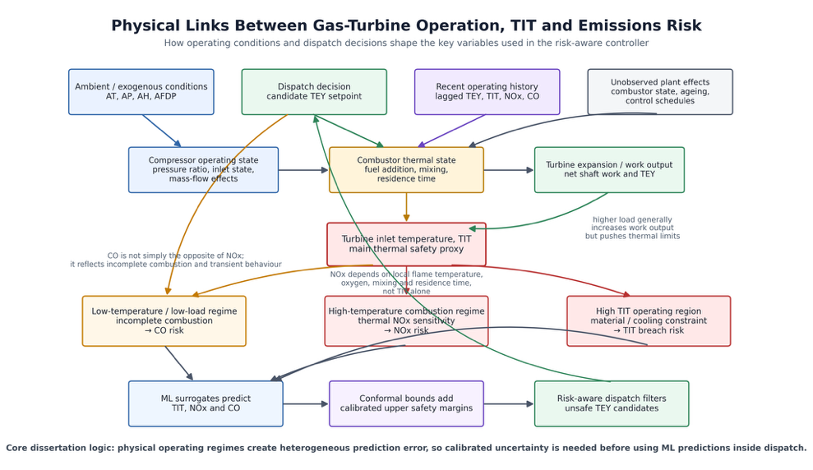
Figure 2 - Physical Links between Gas Turbine operation, TIT, and Emissions risk

TIT Decision Importance
The operational rationale for using turbine inlet temperature (TIT) as a main variable representing safety and economics is not just that higher TIT gives more power. First order work sensitivity to TIT is large in idealized balances. Under the constant $c_{p}$ idealization, turbine specific work is approximately

$$\begin{aligned}w_{t}≈c_{p},t\left(T_{t3}- T_{t4}\right)\#\left(4\right)\end{aligned}$$
Hence,
$$\begin{aligned}\frac{∂w_{t}}{∂T_{t3}}≈c_{p,t}\#\left(5\right)\end{aligned}$$

If $T_{t4}$ weakly depends on $T_{t3}$, even if $T_{t4}$ co-varies, a small $δT_{t3}$ still maps into order-$c_{p}δT$ changes in work, so there is a strong dispatch incentive to run near a temperature constraint.

However, that that sensitivity is not constant near high TIT, because at elevated temperatures, $c_{p}$ depends on temperature and gas composition.
Modern thermochemical formulations represent $c_{p}(T)$, h(T), and s(T) via polynomial fits relative to reference thermochemical tables (such as NASA polynomials and related coefficient sets; NIST-JANAF tables) (Mcbride et al., 2002). As such, a more honest local sensitivity is represented as

$$\begin{aligned}\frac{∂w_{t}}{∂T_{t3}}≈c_{p},t\left(T_{t3}\right)+\left(T_{t3}- T_{t4}\right)dc_{p},\frac{t}{dT}{\left.​\right|}_{T_{t3}}-c_{p},\frac{t\left(T_{t3}\right)∂T_{t4}}{∂T_{t3}}\#\left(6\right)\end{aligned}$$

Which makes it explicit that $c_{p}$ is a function not a constant, and that the turbine exit temperature response matters. This is important because the NACA compressible flow compilation separates perfect gas relations from caloric imperfection corrections, because high temperature applications require acknowledging variable property behaviour(Ames Research Staff and Field, n.d.). Recent engineering studies also show that flue-gas heat capacity depends on both temperature and composition and can be correlated over wide temperature ranges. This reinforces why a surrogate models’ errors can be dependent on regime and heteroskedastic near high load and high temperature regions (Förtsch, 2025).

Industrial and aero gas turbines can reach high turbine inlet temperatures because of advanced internal cooling of hot section components, and thermal barrier coatings. Some reviews of rotating component cooling describe cooling as essential for durability under demanding temperatures and pressures and represent cooling as a major engineering challenge (Unnikrishnan and Yang, 2022). On the materials side, reviews emphasize that TBCs (thermal barrier coatings) operate in demanding environments while identifying failure and degradation as design constraints (Clarke and Levi, 2003).
This matters for learned surrogates because the dispatch optimizer wants to buy power by pushing towards high TIT, but the feasible margin is set by materials/cooling design realities. That creates a structurally high value of risk calibration. The region that is most economically attractive is near the boundary where predictive error has asymmetric consequences (where a small underprediction can still cause a breach) (Saravanamuttoo, 2017).

Pollutant Formation Mechanisms and Temperature Sensitivity for Nox and CO

It can be said mechanistically that many NO formation pathways in combustion can be represented by temperature sensitive kinetics of Arrhenius type:
$$\begin{aligned}k\left(T\right)=AT^{b}exp\left(-\frac{E}{R T}\right)\#\left(7\right)\end{aligned}$$
So that
$$\begin{aligned}∂ln\frac{k}{∂}T=\frac{b}{T}+\frac{E}{R T^{2}}\#\left(8\right)\end{aligned}$$

When T is high and E (activation energy) is large, small $δT$ produces multiplicative changes in reaction rates (k) , inferring that NOx often rises quickly with temperature in high load regimes (Unnikrishnan and Yang, 2022).

It is important to note that TIT is not the same as peak flame temperature, and NO formation depends on local temperature, oxygen availability, mixing, and residence time. As such TIT ↑ ⇒ NOx ↑ is not always valid. It is a proxy relationship whose slope and scatter are dependent on the regime. Due to this, offline regression metrics can be misleading. The highest impact errors are those that occur in the high temperature tail where the kinetics make the system more sensitive (Unnikrishnan and Yang, 2022).

CO emissions are tied to incomplete oxidation. CO tends to be elevated when combustion is too cool, mixing is poor, or residence time is not enough. That means CO is not redundant with NOx. NOx can be considered a ‘hot pathway’ risk, whereas CO is a risk factor for low temperature or stability margin operation.
This asymmetry is one justification for treating CO and NOx jointly in safety aware dispatch, rather than optimizing only one pollutant (Pachauri, 2024).
An important implication here is that an optimizer that only penalizes NOx my shift operation into regimes where CO or other stability indicators may deteriorate. So multi-constraint feasibility is the more defensible position for claims to do with ‘safe dispatch’.

The Public Health
Modern power generating gas turbines emit NOx and CO as regulated pollutants. These emissions vary strongly with load. NOx is emitted primarily as nitric oxide (NO) and nitrogen dioxide (NO2). Once they are released, NO2 and other particles in the NOx family interact with the atmosphere in such a that forms ozone at the ground level and more secondary particulate matter (nitrate aerosols). Both increase respiratory and cardiovascular risk (United States Environmental Protection Agency, 2025a). NO2 but itself is an airway irritant. Exposure to it can aggravate asthma and respiratory disease. Long term exposure is associated with susceptibility to respiratory infections (United States Environmental Protection Agency, 2025a).

CO (carbon monoxide) is a toxic gas that binds to your haemoglobin and can reduce the oxygen delivery to organs. As such, the primary health concern for this pollutant is hypoxic stress for at risk individuals. High exposure can be considered fatal (United States Environmental Protection Agency, 2025b).

Environmental regulators set stack emission limit values and require monitoring, because reducing stack concentrations reduces the chance of exceedances after dispersion.

Data Driven Gas Turbine Emissions Modelling
An important question for data driven gas turbine emissions modelling is whether surrogate models remain useful for decisions near operational limits. Operational limits are where critical decisions would be mostly made when managing risk. The UCI machine learning repository Gas Turbine CO and NOx Emission Data Set (which is used in this methodology) contains ~36k hourly rows of sensor measures, including TIT, TEY (MWh) and emissions (CO, NOx) in mg/m3. The samples are in chronological order and recommends a specific time-based evaluation protocol for ‘reproducibility and comparability’ (UCI Machine Learning Repository, 2019).

Recent studies using this dataset are usually organized around feature engineering and model selection. They also report good point prediction metrics. For example, a 2024 study evaluates multiple regressors, and reports strong training performance but weaker validation performance, which infers bad performance in generalization(dos Santos Coelho et al., 2024b). Another 2024 paper shows improved RMSE vs baseline ML regressors, and giving motivation for emissions monitoring for compliance, in an offline context (Pachauri, 2024). A GPPS contribution frames the task as multivariate time series regression and compares deep learning architectures and feature-extraction approaches for CO/NOx prediction (Jhinaoui et al., n.d.). A 2023 comparison argues that ML outperforms physics-based models (Potts et al., 2023).
These papers collectively support a certain conclusion, that offline predictive accuracy can be high, and modern approaches are competitive.

However, from a decision and control perspective, offline metrics are not enough. Temporal dependence and shifts in regime means that random splits can leak information and unreasonably increase confidence in generalization, especially when the real deployment is sequential and nonstationary. In addition, tail relevance must be considered. Operations care about exceedances of limits (thermal, emissions). An RMSE that looks good on average can still hide systematic underprediction near the upper tail where constraints bind. Compressible-flow and thermochemistry theory makes it clear that high temperature conditions are where idealizations degrade and sensitivities increase. As such, the data tails are an operationally dominant region for safety.
Furthermore, once a predictor is embedded in an optimizer, the optimizer will preferentially chose inputs that look good under the model. This changes the realized distribution of operating points compared with the training data. This can create systemic bias and invalidate naïve calibration arguments unless they are accounted for specifically (Perdomo et al., 2020).

As per what is seen in those papers, a more defensible evaluation would combine:
(A) Contiguous time splits
(B) Regime conditioned evaluation as physics and error structure is regime dependent
(C) Tail metrics targeted to exceedance risk rather than global RMSE (Angelopoulos et al., 2025)
(D) Closed loop evaluation where model is assessed based on constraint breaches, feasibility failures, and economic/emissions outcomes.
(Tibshirani et al., 2019).

Optimizer-In-The-Loop Approach
In power system optimization, surveys of ML-assisted optimization show that surrogate models can reduce computational burden and allow for faster optimization loops, but they also show generalization and reliability risks when operating conditions shift or when constraints are evaluated under approximation (Tibshirani et al., 2019).

A conceptual difficulty, which is very relevant to dispatch, is that optimization changes what is seen. When the optimizer uses a surrogate, it chooses actions based on the learned structure from the surrogate, which could potentially drive the system into regions where the predictions are less reliable. This aligns with the concept of performative prediction, which formalizes settings where prediction influences outcomes and thusly shifts the data distribution. This effect is an endogenous distribution shift (J. C. Perdomo et al., 2020). This matters from the perspective of uncertainty calibration because calibration guarantees rely on exchangeability (no points is probabilistically special relative to one another) or stable sampling (all new points are drawn under the same sampling rules as earlier ones).

Conformal methods under covariate shift (a type of distribution shift where the input distribution changes between training and deployment) relaxes the requirement for exchangeability via weights when the likelihood ratio can be estimated, which allows us to talk about train-test input difference in a precise way (Tibshirani et al., 2019). In optimization or design loops, the model helps choose which cases get tested, so the real-world data depend on the model. This formalizes the idea that that the optimizer tends to pick cases the model thinks looks good (Xu and Xie, 2021).

When a dispatcher selects TEY setpoints based on predicted targets, the realized residual distribution can be different from the calibration residual distribution unless the simulation and calibration method intentionally reproduces the optimized selection. The later talked about implementation of simulated independent trajectories and calibrated gating is a direct response to a known failure mode in ML + optimization deployment.

Distribution-Free Calibration and Risk Control
This project is concerned with imperfect and regime dependant surrogate models where the optimiser can shift the operating distribution. Because of this distribution free calibration and conformal risk control are introduced as the mechanism for turning prediction uncertainty into a usable safety margin.

Conformal prediction provides a way to take a models point predictions and add an uncertainty range around them (conformal prediction). A prediction interval such that over many future cases, the true value falls inside the range about as often as promised by the definition (marginal coverage). This is called distribution-free because the guarantee does not require assuming a particular data distribution, but it does however rely on the idea that past examples used for calibration and the future examples that are predicted are drawn in the same way, so their order can be changed without changing results (exchangeability). All these reasons are why conformal prediction useful for calibrating models, especially black box prediction engines.

For data that is time ordered, the assumption that ‘order doesn’t matter’ fails because nearby time points are related. This temporal dependence violates exchangeability. Methods such as EnbPl are designed for this, where they produce uncertainty ranges step-by-step as new data arrives using many refit models built from resampled data and recalibrating using a moving window the most recent observations (Xu and Xie, 2021).
Adaptive conformal inference (ACI) goes even further by adjusting calibration online to maintain coverage under a shift of distribution (Gibbs and Candès, 2021).
Theres a two-sided take-away here. Conformal tools are useful because they are agnostic to the type of model used, and calibrated, but the literature also shows that sequential dependence and distribution shift requires adaptation to algorithms.

Conformal Risk Control (CRC) generalizes conformal calibration from making prediction intervals that hit the true value most of the time. Instead, it lets you set and guarantee a target level for how often a chosen kind of bad outcome happens on average. It uses an error score where larger mistakes count as worse. This makes it useful for calibrating the chance of specific events.(Angelopoulos et al., 2025).
This is a good match for operational dispatch because many real constraints are exactly in that form of exceedance events.

Conformal events ideas have been integrated into safety focused planning by constructing uncertainty sets for predicted trajectories and enforcing them in an optimization loop. A particular “conformal MPC” work argues that conformal prediction regions can be used to provide probabilistic safety guarantees, when planning amid uncertain dynamics (Lindemann et al., 2023b). More related work on conformal prediction looks at how to update and report uncertainty in real time under sequential data streams (Dixit et al., 2023).
For turbine dispatch, the value of this literature is less in copying the specific formulations and more in the value of adopting the cautions they prescribe. When the system’s choices are influenced by the model, the results can’t be trusted by default, so you must design the process carefully to avoid biased data caused by only looking at cases that pass the chosen constraints.

Multi-Objective Economic-Emissions Trade Offs
As the project studies economic dispatch under imperfect learned plant models, the economic–emissions trade-off must be understood as a frontier that is reshaped by uncertainty calibration, feasibility and risk control.

The e constraint method generates ‘Pareto-efficient’ solutions by optimizing a primary object while turning other objectives into constraints. It sweeps a parameter e to trace this frontier. Previous works show that e-constraint has advantages over regular weighting (which can miss parts of the frontier and is sensitive to scaling), but also shows important issues, such as choosing e ranges, avoiding weakly efficient points, and producing well distributed frontiers (Mavrotas, 2009).

In a dispatch setting where the primary objective is economic value and the constrained objective is NOx, the formulation is
$$\begin{aligned}\max_{u∈U }{J\left(u\right)}s.t.{ E}_{\left(NOx\right)\left(u\right)}≤ε,and operational/safety constraints\#\left(9\right)\end{aligned}$$

This can be interpreted through the Lagrangian:

$$\begin{aligned}L\left(u,λ\right)=J\left(u\right)-λ\left(E_{\left(\text{NOx}\right)\left(u\right)}-ε\right)\#\left(10\right)\end{aligned}$$

Where, at an efficient point, the variable $\left(λ^{*}≥0\right)$ acts a local shadow price - shadow price being the implied marginal value of relaxing/tightening the cap on NOx. This provides a way to interpret economy/NOx slopes along the frontier as marginal costs of NOx reduction (Mavrotas, 2009).

However critically, the MAC curve literature warns that marginal abatement cost curves can be misleading if treated as uniquely determined objects, because they depend on modelling assumptions and interactions that can be hidden (Kesicki and Strachan, 2011). In this context of this methodology, analogously it can be said that the apparent ‘price’ of NOx reduction depends not only on the optimizer formulation, but also on the surrogate’s calibration near the constraint boundary and on feasibility filtering (conformal margins and breach probability). Therefore, the frontier is a risk conditioned object that is reported with breach and feasible hour fractions.

Methodology

Problem Setup
An hourly dispatch problem over a time horizon is considered defined as

$$t=1…T$$

At each time t, the operator sets the turbine yield $u_{t } ≥0$MWh. The ambient exogenous variables (temperature, pressure, humidity, filter pressure, etc.) and the previous operational states $u_{t-1}, TIT_{t-1}, NOx_{t-1}, CO_{t-1}$, are assumed known at time t. The surrogate then predict that at time t the $TIT_{t}$ and the emissions $NOx\left(x,t\right), CO_{t}$ will be some functions of $\left(u_{t},AT_{t},AP_{t},AH_{t},AFDP_{t}\right)$ and the lag past state.
Let
$$\hat{Y_{t}}=f_{\left(point\right)}^{\left(Y\right)}\left(x_{t};w\right)$$

be the point prediction model for outcome $Y∈\left\{“TIT”,”NOx”,”CO”\right\},$where $x_{t}$ collects the known inputs (including $u_{t}$ and the lagged states) at time t. W denotes the learned model parameters. An upper quantile model

$$f_{τ}^{\left(Y\right)}\left(x_{t}\right)$$

Is also trained to estimate the $τ$-quantile of Y, however the online optimization constraints below are enforced using conformalised upper bounds built from point prediction residual calibration. (See Conformal Upper Bounds).

Economic Objective
The economic objective at time t is set to maximize a net value function defined as:

$$\begin{aligned}J_{t}\left(u_{t}\right)=\underset{\left(revenue\right)}{\underbrace{\left(Pu_{t}\right)}}-\underset{\left(fuel\right)}{\underbrace{\left(C_{\left(fuel\right)}\left(u_{t}\right)\right)}}-\underset{\left(wear\right)}{\underbrace{\left(C_{\left(wear\right)}\left(\overline{TIT_{t}}\right)\right)}}-\underset{\left(environment\right)}{\underbrace{\left(C_{\left(env\right)}\left(\overline{NOx_{t}},\overline{CO_{t}}\right)\right)}}.\#\left(11\right)\end{aligned}$$

In the implementation, placeholder cost coefficients are used:

$$\begin{aligned}C_{\left(fuel\right)}\left(u_{t}\right)=0.5u_{t},{ C}_{\left(wear\right)}\left(\overline{TIT_{t}}\right)=0.1\overline{TIT_{t}},C_{\left(env\right)}\left(\overline{NOx_{t}},\overline{CO_{t}}\right)=0.2w_{\left(NOx\right)}\overline{NOx_{t}}+0.05\overline{CO_{t}}\#\left(12\right)\end{aligned}$$

With a fixed price P (P=10). The Nox weight is 1 by default and is increased during $ε$-frontier sweeps to increase the illustrative influence of Nox in the objective.

Operational And Safety Constraints
The control variable includes operational constraints. TEY is required to be ‘feasible based on:

$$u_{t}∈\left[u_{min},u_{max}\right]$$

In the implementation $u_{min}$ is the 5th percentile of the training set of TEY, and $u_{max}$ is the 95th percentile.

A fixed grid of candidate $u_{t}$ values is used and solved via enumeration.

Safety constraints are implemented using proxy limits. Let

$$\overline{TIT},\overline{NOx},\overline{CO}$$

be allowable upper limits on the targets. These are set as 95 percent of the training data for each variable.
As predictions have error, these limits are enforced using calibrated upper bounds. For each

For each $Y∈\text{TIT},\text{NOx},\text{CO}$, we define a conformal upper bound $\hat{Y_{t}^{\left(\text{upper}\right)}}\left(u_{t}\right)$ (see 3.1.3). The safety constraints are therefore:
$$\hat{TIT_{t}^{\left(upper\right)}}\left(u_{t}\right)≤\overline{TIT},$$
$$\hat{NOx_{t}^{\left(upper\right)}}\left(u_{t}\right)≤\overline{NOx},$$
$$\hat{CO_{t}^{\left(upper\right)}}\left(u_{t}\right)≤\overline{CO}.$$

A learned classifier for the probability of breaches occurring is used as a ‘CRC gate’. For each candidate $u_{t}$, breach probabilities are calculated for every output, and an ‘any breach’ score is calculated as:

$$\begin{aligned}s_{\left(any\right)}\left(u_{t}\right)=maxs_{\left(NOX\right)}\left(u_{t}\right),s_{\left(TIT\right)}\left(u_{t}\right),s_{\left(CO\right)}\left(u_{t}\right)\#\left(13\right)\end{aligned}$$

A calibrated threshold $λ\left(α\right)$ is applied:
$$s_{\text{any}}\left(u_{t}\right)≤λ\left(α\right).$$

Conformal Upper Bounds
Recall that we define the point prediction as
$$\hat{Y_{t}}=f_{\left(point\right)}^{\left(Y\right)}\left(x_{t}\right)$$

Calibration residuals $r^{\left(Y\right)}=Y-\hat{Y}$ are used; a 1-$α$ upper residual quantile is computed as $q_{Y}\left(α\right)$. Therefore, in online usage, the calibrated upper bound is:
$$\begin{aligned}\hat{Y_{t}^{\left(\text{upper}\right)}}\left(u_{t}\right)=\hat{Y_{t}}\left(u_{t}\right)+q_{Y}\left(α\right)\#\left(14\right)\end{aligned}$$

This is applied separately for each target.

Controller Optimizer Per Hour
Per hour t, the controller solves for
$$\begin{aligned}max_{\left(u_{t}∈\left(U\right)\right)}{=J}_{t}\left(u_{t}\right)\#\left(15\right)\end{aligned}$$

This is solved subject to all the predefined constraints.
Since U is a finite TEY candidate grid, this problem solved via enumeration.

Control Of Risk Parameters
Two main risk controls are used in this methodology.
The first is $α$ which controls miscoverage and risk level, where miscoverage is the event that any stated guarantee fails, which is to say the true value falls outside the predicted set. It is an array of values used to decide the conformal residual quantities that define $Y_{t}^{\left(\text{upper}\right)}$, and it calibrates the CRC threshold via conformal risk control so that the corrected expected any-breach loss does not exceed $α$. This fixed grid of a is defined in this set as [0.05, 0.07, 0.1, 0.15, 0.2].

Secondly, we have $ϵ$ (the NOx cap). It is varied to trace a –economics Pareto frontier. In these sweeps, one can increase the Nox penalty weight so for the sake of clearer results or to align with regulations, you can have a clearer Pareto separation between the economic return and strictness of the constraints.

Surrogate Model Training

Reasoning For Gradient Boosted Trees Over NNs

What is LightGBM?
LightGBM (Light gradient boosting machine) Is a type of gradient boosting decision tree (GBDT). It is a model that builds a set of decision trees to minimize a loss. It is a supervised model (Ke et al., n.d.).

If given training data ${\left(x_{i},y_{i}\right)}_{\left(i=1\right)}^{n}$ and loss $l\left(y,F\left(x\right)\right)$, gradient boosting creates a predictor defined as:

$$\begin{aligned}F_{M}\left(x\right)=sum_{\left(m=1\right)}^{M}ηf_{m}\left(x\right)\#\left(16\right)\end{aligned}$$

Where each $f_{m}$ is a regression tree, and n is a learning rate. At an iteration m, the algorithm uses gradients defined as:

$$\begin{aligned}g_{i}=\left(∂l\left(y_{i},F\left(x_{i}\right)\right)\right)/\left(∂F\left(x_{i}\right)\right){\left.​\right|}_{\left(F=F_{\left(m-1\right)}\right)}\#\left(17\right)\end{aligned}$$

This is the training signal used to choose splits that reduce loss the most.

LightGBM evaluates a possible split by checking how well it separates the data into left and right groups where the loss gradients are strongest. It is computed from the sums of gradients in each child group and selects the split with the largest gain.

Why Use Gradient Boosted Trees Over A Custom MLP?
Gradient boosted decision trees (LightGBM in this implementation) is used as the surrogate model because the problem is mostly tabular, mixed scale data that requires fast retraining and iteration. Fast retraining is important in an operator setting where the model is being updated live with more data, and iteration is important in the development environment. LightGBM is designed to train GBDT models efficiently whilst retaining good accuracy. (Ke et al., n.d.).

Compared to neural networks, trees tend to have a stronger performance on medium sized tabular datasets (such as the one used in this study) without tuning. They are also less sensitive to feature scaling and architecture choices. Studies show that tree based predictive methods are very competitive and often perform better on tabular prediction, before considering the cost of tuning NN models. (Grinsztajn et al., 2022).

Since the methodology presented in this paper relies on surrogates that can trained and validated quickly, LightGBM is an appropriate approach.

Specific Surrogate Implementation Used

The surrogate definition and setup can be found in Appendix B

Separate surrogates are trained for the targets TIT, Nox and CO.
The data is assigned to a sequential array and sorted chronologically.
Masks are created via a split
- 70% train
- 15% calibration
- 15% test
These splits are in earliest – latest order.
For each hour t, the feature vector includes

$$x_{t}=\left[AT_{t},AP_{t},AH_{t},AFDP_{t},u_{t},\text{time features},\text{lagged state features}\right]$$

Where $u_{t}$ corresponds to TEY (the dispatch decision).
Notice not all features of the original dataset are included to prevent leakage. This is further explored in Failure Modes.

For each target Y, two LightGBM regressors are trained. The first is the point model

$$\hat{Y_{t}}=f_{\left(point\right)}^{\left(Y\right)}\left(x_{t}\right)$$

And the upper quantile model (later used for the CQR bounds and evaluation)

$$\hat{q_{t}}=f_{τ}^{\left(Y\right)}\left(x_{t}\right), τ=0.95$$

Both models use the same core hyperparameters defined in appendix B.

In terms of evaluation, for point models, MAE and $R^{2}$are computed on TRAIN / CALIBRATION / TEST split.

For quantile models, pinball loss and empirical coverage $Pr⁡(Y≤\hat{q})$are computed on TRAIN / CALIBRATION / TEST (nominal target $≈τ$).

Calibration residuals from the point model on the CALIBRATION split are saved for downstream conformal upper bounds, and CQR scores based on $Y-\hat{q}$ are computed.

Hyperparameter tuning and justification
Hyperparameter choices for the surrogates can be found in appendix B

The surrogate hyperparameters were chosen to be conservative and reliable rather than aggressively tuned for pure accuracy. There is a low learning rate, high tree a cap and early stopping that provides stable fitting. The row and feature subsampling regularise the model and the tau = 0.95 matches the safety role of the upper tail model. The settings were chosen to enable fast retraining in testing, with decent generalisation. These provided satisfactory results.

Lags And Their Physical Significance in Emission Prediction
Lag features are created that hold 3 previous hours of any given feature/target.

To avoid leakage and retain a desirable signal, all the targets use the baseline exogenous features, plus the time features, plus a baseline single hour lag feature:

$$TEY_{\left(t-1\right)},TIT_{\left(t-1\right)},GTEP_{\left(t-1\right)},TAT_{\left(t-1\right)},CDP_{\left(t-1\right)}$$

Rows are dropped until all the required lagged features are available to the model.

The NOx and CO model additional includes lag states 1-3 to improve prediction accuracy. Gas turbine emissions have memory. During load changes and variation in ambient conditions, the internal states relax over time so the conditions at any given moment depend on the recent operating history. This is due to effects like heat transfer and soaking that define future performance (Yang et al., 2024). In this dataset, each row is an hourly aggregate, so a single hour can mix steady periods and transients; lags help the surrogate infer whether hour t follows a ramp-up, ramp-down, or settled regime, improving accuracy especially near constraint boundaries.

Initial prediction accuracies were very challenging before lags were introduced, proving that transient information is essential to correctly prediction these emissions.

Conformal Calibration
For each of the outputs TIT, NOx and CO, the controller requires an upper (one sided) safety margin that can be calculated cheaply for every setpoint. As such, a split conformal upper bound is implemented as a residual translation of the point surrogate. The single predictions are taken, and then a safety margin is added based on the past prediction errors. This is the standard implementation for one-sided conformal prediction of this form (Fontana et al., 2023),

After training each point surrogate, the residuals are computed not on the training set, but the calibration set

$$r_{i}^{Y}=y_{i}^{Y}-{\hat{y}}_{i}^{Y}, i=1,…,n_{cal}.$$
We also let
$$r_{\left(1\right)}^{Y}≤…≤r_{\left(n_{cal}\right)}^{Y}$$

be the sorted set of residuals. The conformal slack (safety margin added to the point prediction so the resulting bound achieves the target coverage) is computed using the finite-sample order statistic index:

$k=\left\lceil \left(n_{cal}+1\right)\left(1-α\right)\right\rceil$ $\begin{aligned}=r_{\left(k\right)}^{Y}\#\left(18\right)\end{aligned}$
(Shafer and Vovk, 2008)
Given a vector x that defines the candidate feature set, including the TEY setpoint, the per target conformal upper bound is
$$\begin{aligned}{\hat{U}}_{Y}\left(x;α\right)={\hat{y}}^{\left(Y\right)}\left(x\right)+{\hat{q}}_{Y}\left(α\right)\#\left(19\right)\end{aligned}$$

This choice can be justified due to the fact the one sidedness concentrates the calibration on the relevant tail, and the translation form keeps the safety evaluation constant-time and stable across the candidate TEYs, which is important as it calculates many candidates per operation hour.

Because predictions errors for the emissions and temperature are likely heteroskedastic across operation, an upper quantile model at the 95th percentile is also fit. The n a conformal quantile regression (CQR) is fitted on the calibration data using the usual conformal score values (these are based on how far observations fall above the predicted quantile) for diagnostics.

Operating under the assumption that the calibration data and future test points are exchangeable (exchangeability), the one sided conformal upper bound has a finite sample marginal guarantee defined as:

$$\begin{aligned}\operatorname{Pr}\left(Y≤{\hat{U}}_{Y}\left(X;α\right)\right)≥1-α\#\left(20\right)\end{aligned}$$

Which is essentially saying for any given target Y, the true value will be below the upper bound at least 1-$α$ times, and this holds separately for each target.

Since the TIT, NOx and CO limits are enforced at the same time, a good performance on each limit by itself does not guarantee that the chance of violating at least one limit is controlled. To be clear, even if each constraint rarely fails or is infeasible when checked individually the probability that one or more constraints can still be higher.

The implementation logs, for every decision three separate decisions. Was TIT violated, was NOx violated, and was CO violated? It then has one combined log, was ANY constraint violated? This is true of any of the three flags are true.

It logs both the per constraint violation rates and the overall, any-violation rate.

CRC Threshold
The conformal upper bounds control the model error on each prediction, but they don’t directly control the decision induced frequency of breaches of said constraints once the operator makes its decision. This is considered endogenous distribution shift as the resultant change in data distribution is caused by the model or decision system itself. This mechanism is formalized in performative prediction, where decisions taken using a model can change the distribution of the outcomes (J. Perdomo et al., 2020).

As such, the implementation adds a separate gating layer of which’s purpose is to control an operator specified risk variable a on a loss function measures whether and by how much a quantity exceeds the specified limit. It can therefore be said that for each constraint variable, a binary breach label is defined on the training split using the same proxy limits used by the dispatch constraints
$$\begin{aligned}B^{\left(Y\right)}=1\left\{Y>\overline{Y}\right\}\#\left(21\right)\end{aligned}$$

This is implemented by computing the proxy limits from the train data, and training three LightGBM classifiers to predict $B^{Y}$ from the same feature et used by the surrogates.
At runtime these classifiers produce scores per candidate hour

$$\begin{aligned}s^{\left(Y\right)}\left(x,u\right)∈\left[0,1\right]\#\left(22\right)\end{aligned}$$

The gate combines them into the any-breach score used to filter the candidate TEY actions before maximization for the objective.
It is important to note that this method does not require the classifier probabilities to be calibrated. A benefit of conformal risk control is that it only needs a scalar score that is subject to a threshold, because the threshold itself is calibrated distribution free.

The cutoff gate λ ($α$) is not chosen heuristically. It learns the cutoff from using data from the CRC calibration step where each data point is a whole simulated run of the controller, rather than a single sample. This choice is significant for multiple reasons. The cutoff λ ($α$) changes which candidate actions are allowed, which changes the actions the controller takes, which changes which states the system visit*, which in turn changes the observed rate of constraint breaches.
As such, the breach statistics that the operator cares about depends on the gate itself. Calibrating the λ ($α$) on the closed loop trajectories make the calibration data reflect the same distribution that will be seen at deployment.

In other words, the calibration is done with the controller within the loop, rather than calibrating on a fixed open loop score that ignores how the method alters what is observed.

A larger λ($α$) should increase the allowed hours and therefore increase risk. However, since the risk is found from a finite number of trajectories, Monte Carlo noise can make the measured loss sometimes reduce at higher λ. To fix this, the monotonizes the loss curve over the λ gride by taking a cumulative maximum. At each λ the reported loss is replaced by the largest loss seen at any small λ.
This stabilizes the calibration and enforces the monotone loss condition that is required by conformal risk control.

If we let $\hat{R}(λ)$ be the mean trajectory loss over the trajectories, then it can be said the correction is defined as

$$\begin{aligned}{\hat{R}}_{\left(corr\right)}\left(λ\right)=\frac{1+\hat{n}\left\{R\right\}\left(λ\right)}{n+1}\#\left(23\right)\end{aligned}$$

This correction is standard in conformal risk control guarantees for bounded monotone losses under exchangeability (Angelopoulos et al., 2025).

*’The states the system visits’ means the sequence of actual operating conditions the system passes through over time

The following diagram displays a flow chart of the dispatch hierarchy:
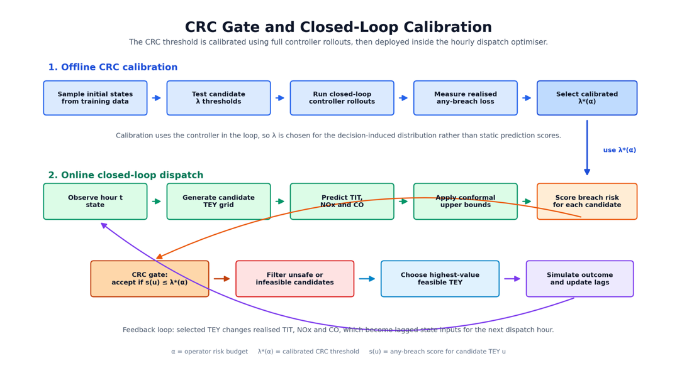
Figure 3 - CRC and Closed Loop Calibration

Closed Loop Simulator
To measure how well the controller performs under feedback (when its own decisions affects future hours), it is tested in a closed-loop simulation in a receding horizon. Each hour, the controller uses the latest state, solves the constrained optimization again, applies the optimised action, and then moves onto the next state.
This is consistent with standard model predictive control methods. (J. Perdomo et al., 2020)

The simulator separates the exogenous inputs from the endogenous state that evolves under the controller’s decisions.
In terms of inputs, for each simulated how t, the ambient and other non-controlled signals are (ATt​, APt​, AHt​, AFDPt​), and a time index hour are taken from the dataset for that hour. These are immutable, observed, and uninfluenced by the controller.

Here we define a term ‘policy’. The policy means the rule/s the controller uses to choose the next action from the current information that is available to it. Consider the policy just the set of rules describing each decision.

The policy’s information state is represented by a stack of lagged process variables, which are advanced deterministically each step. The controller has a dense history buffer per state variable, but it only passes the selected past values exactly needed by the optimizer in the optimization step. This makes sure that the lagged features correctly propagate under all conditions.

When rolling out the simulator under the test set, the code should initialise to the lagged state using the final row from the calibration period, which gives the first test time steps realistic recent history instead of starting with empty or artificial past values. When running the CRC calibration rollout, the initial state is instead taken by sampling a starting row from the training data. This is because a lagged model cannot make a realistic prediction at the first simulated hour unless it knows the recent past, and seeding in this way allows for plausible operation.

Inner Loop

At each hour, the simulator constructs a candidate set of actions
$$u∈U$$
as an evenly spaced grid between the 5th and 95th percentile (to avoid extreme extrapolation) of the training set of TEY.

For each possible action, the implementation checks whether it satisfies the TIT/NOx/ CO upper bound limits, the CRC risk gate, and extra NOx cap rule for better pareto results. Only actions that pass all active checks are allowed. If no action passes, that time step is marked infeasible, and the code records which constraint blocked the most candidates.

To close the loop, the simulator needs a model of realized outcomes after applying the chosen action.
The implementation uses a nonparametric residual resampling model defined as:

$$\begin{aligned}Y_{t}^{\text{sim}}=\hat{Y_{t}}\left(u_{t}\right)+\tilde{r_{Y}}\#\left(24\right)\end{aligned}$$

$$\tilde{r_{Y}}∼\text{Unif}\{r_{i}^{\left(Y\right)}\}_{i∈\text{CALIB}}$$

This is applied independently for $Y∈\{TIT,NOX,CO\}$, where the calibration residuals are computed on the calibration split and stored as arrays for sampling later.

The simulation creates outcomes in two parts. One is the surrogate where it’s the model’s prediction for what should happen after an action, and one is the empirical disturbance, which is a randomly sampled past prediction error taken from the calibration residuals. This means that instead of assuming a fixed noise model, the code uses the actual error patterns seen in past data, defining the ‘distribution free’ requirement earlier discussed.
This can be compared to a residual bootstrap, where error is approximated by past data rather than a parametric form, allowed you to test the controller in a difficult but realistic setting where the optimiser keeps choosing actions close to the defined limits. These boundary cases are where the calibration and gating matter the most because small prediction errors can decide whether a constraint is satisfied or violated.
(Efron, 1979; Freedman, 1981).

After the simulator generates the actual outcome for the current hour, it updates the systems memory of recent past values by moving each history buffer forward by one step and adding the newest realized values for the targets and TEY. For unused unmodeled lagged variables it just copies the observed value from the matching row in the dataset when updating for the new state.

At each hour the simulator records 4 things:
- The chosen action and data surrounding it
- The simulated realized outputs and whether breaches occurred
- Conformal audit flags which mark whether the realized value was above those hours calibrated upper bound
- Per hour Feasibility data

This logging is important because conformal calibration is only meaningful in terms of what ends up occurring during operation. (Lei et al., n.d.).

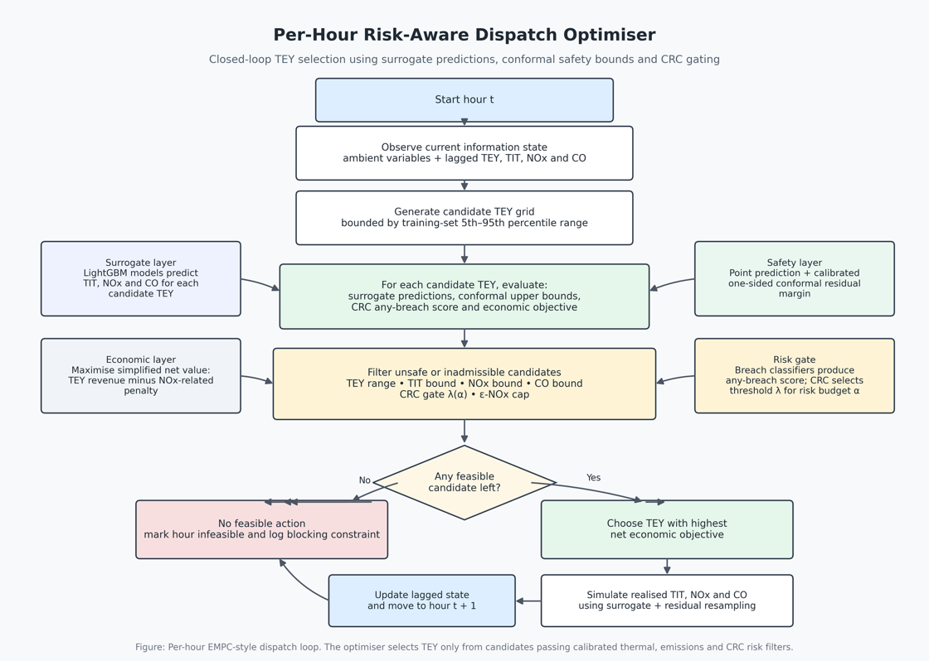
Figure 4 - Per hour dispatch optimiser

Assumptions, Limitations, Complexity

Assumptions
The controller implementation does not assume full plant stationarity, meaning that the plants underlying behaviour is not assumed to be stable in the time domain. It does however assume that the chosen lagged state representation is sufficiently informative for accurate approximation at the scale. Aspects like slow thermal memory, actuator hysteresis, the state of maintenance and other plant effects are all absorbed into the residual error.

A second assumption is the transferability of calibration. The conformal upper bounds and CRC are calibrated and reused in the closed loop simulation, which in effect assumes that the uncertainty that is faced during deployment is similar enough to the uncertainty seen in calibration. This assumption wants the logic to remain informative through these splits. This assumption is however justified because conformal prediction gives marginal validity under exchangeability, and CRC extends the same calibration logic to monotone risks. However, with turbine data, that interpretation becomes approximate rather than exact, since exchangeability can be violated by non-stationarity. (Lei et al., n.d.)(Angelopoulos and Bates, 2022)(Xu and Xie, 2021).

Thirdly, the methodology assumes that safety can be totally captured by exceedance events, rather than knowing the full probability distribution of outputs. This makes sense for operators because they directly care about whether temperature or emissions limits are breached, however the code only can control that event-based risk. It cannot provide a probabilistic calibration of the outputs and thus cannot make claims that have equally strong validity in every operating condition. (Foygel Barber et al., 2021).

Limitations
The controller picks TEY setpoints based on what the surrogate predicts will look best. Because of that, it will keep choosing operating conditions that the model rates as attractive and will spend less time in other parts of the operating range. As a result of this, the data the plant produces after deployment may no longer look like the data used to train and calibrate the model. The train-calibrate-test and closed loop setup help because they test the method in a more realistic way than checking one step prediction accuracy offline, but it still doesn’t completely solve the problem. Once the model starts influencing which actions are taken, it also starts influencing which data gets observed, so the real-world data distribution can shift because of the model itself. This is a core tenet of performative prediction theory. (J. C. Perdomo et al., 2020).

Related to this the uncertainty guarantees apply mainly in a average sense, not for every specific operating condition. SO even if the method controls breach well on average, it can still be less reliable in rare or poorly represented parts of the operating range, such as in unusual weather conditions or extreme temperature cases.

Another limit is that the methodology is limited in its external validity. It is trained and evaluated on a single public gas-turbine, uses proxy caps, and has illustrative economic coefficients. In addition, the dispatch omits several operational constraints that matter in practice like ramping, start up and shut down logic, variation in fuel types and quality, aging of components etc. Such a design is suitable for a methodological demonstration, but broad and defensible claims for deployment outside of this sample are unjustifiable without more external validation, additional plants or time splits. (Collins et al., 2024)

There is a limitation based on the structural modelling of the methodology. This is based on the choice to use separate target wise surrogates and breach models. This allows training and inference to be fast and modular, but it also means that dependence between targets is only handled indirectly through the ‘any-breach’ gate and the shared features. This is a more pragmatic approach to protect against exceedance, rather than using a more explicit, multivariate and stochastic model of the targets.

The controller works via grids and a one-step greedy search. As such, it inherits the limitations imposed by them. Enumerating a fixed grid makes the dispatch logic robust, but it can miss better hours depending on the grid size and it doesn’t optimise over long intertemporal horizons (meaning the span of future time periods over which decisions are planned and linked together). As such, the frontiers seen is results should be understood as showing the trade-offs achieved by the specific one step and update control policy, rather than the best possible trade offs for the economics and pollutants.

Computational Complexity

Current Offline Implementation Complexity
For this section the nomenclature can be found in appendix C1

Gradient Boosted trees are a histogram based boosting method, so a proxy for the order of training is linear in sample size, feature count, and boosting rounds (Ke et al., n.d.).

$$\begin{aligned}C_{it}=\sum_{t=1}^{P}{O\left(N_{tr}d_{t}\left(M_{t}^{pt}+M_{t}^{gu}+M_{t}^{br}\right)\right)}\#\left(25\right)\end{aligned}$$

The conformal stage is cheaper than fitting the model, but in the implementation, it is repeated over all the risk levels and uses sorting-based quantile extraction on the calibration residuals. This yields:

$$C_{\text{conf}}=O\left(PAN_{\text{cal}}\log{N_{\text{cal}}}\right)$$

In here CRC isn’t just used in the thresholding, it also relies on the extra breach classifiers defined above, and then it calibrates a threshold by the simulated rollouts. The theory states that it expects a loss up to the O(1/n) term, but the implementation cost is instead driven by the amount of simulated trajectories and candidates for the thresholds.

If we let $c_{cand}$ be the cost of evaluating all the fitted models, each dispatch step enumerates a TEY grid, predicts the targets and breach probabilities for all candidates, and applies the conformal and CRC feasibility masks, and picks the best economic objective. As such:
$$C_{\text{hour}}=O\left(G_{\text{cand}}\right)$$

Over T hours, the baseline frontier costs $O\left(ATG_{\text{cand}}\right)$. CRC calibration costs

$$C_{\text{CRC}}=O\left(ALRHG_{\text{cand}}\right)$$
And the e-constraint sweep adds a factor of
$$Cε​=O\left(AETGc_{cand}​\right)$$
Therefore, the complexity could be defined as:

$$\begin{aligned}C_{\text{offline}}=C_{\text{fit}}+O\left(PAN_{\text{cal}}\log{N_{\text{cal}}}\right)+O\left(ALRHG_{\text{cand}}\right)+O\left(ATG_{\text{cand}}\right)+O\left(AETG_{\text{cand}}\right)\#\left(26\right)\end{aligned}$$

If new data were added sequentially in a live system
The current implementation does not have live streaming updates. If a new hour were added and the saved models, conformal summaries and CRC thresholds were kept, then it would still cost:

$$C_{\text{live}\text{/}\text{hour}}=O\left(G_{\text{cand}}\right)$$

If, however, the same batch pipeline was rerun whenever new data arrived, then after t arrivals with Nt = N0 + t,

$$\begin{aligned}C_{\text{refit}}\left(t\right)≈\sum_{j=1}^{P}{O\left(N_{t}d_{j}\left(M_{j}^{pt}+M_{j}^{gu}+M_{j}^{br}\right)\right)}\#\left(27\right)\end{aligned}$$

Repeating that after every new arrival of data gives a cumulative cost that grows about quadratically in the live situation. Thus, for a live implementation, computation becomes expensive unless the offline artifacts are fixed or refreshed infrequently.

Issues encountered

Low model accuracy without considering time dynamics

All results for this section can be found in appendix B7

Initially the system was modelled in the surrogate without lagged features. That design as acceptable for TIT, but it performed badly for the emissions targets. On the test split, the no-lag model gave TIT MAE = 3.08, RMSE = 4.04, and R² = 0.956, but NOx deteriorated badly to MAE = 12.20, RMSE = 14.07, and R² = -1.82, while CO only reached MAE = 0.791, RMSE = 1.36, and R² = 0.535.
The tail diagnostics showed the same issue, where the NOx test pinball was 1.040 and CO empirical coverage was only 0.749. This is an indicator weak upper tail reliability, which is perhaps the most important aspect for the projects constraint logic.

I realised this was a modelling problem rather than a hyperparameter tuning problem. In this dataset, each observation uses chronological splits, so the current row can still reflect recent thermal relaxation, and incomplete settling from previous hours. Gas-turbine transient studies also show that load changes and ambient variation shift the system away from thermal equilibrium, while emissions depend on combustion temperature, time, and related internal states rather than on just instantaneous inputs. This is to say, NOx and CO are partly state-dependent and therefore need recent operating history to be inferred properly (As discussed in the Lag section).

I therefore added lagged state features, with three previous hours included for the emissions models. After doing so, the final test results improved materially.
TIT improved to MAE = 2.15, RMSE = 2.94, and R² = 0.976. The largest gain was in NOx, which improved to MAE = 3.91, RMSE = 5.13, and R² = 0.625. CO also improved to MAE = 0.456, RMSE = 1.04, and R² = 0.731. The tail metrics improved as well: NOx pinball fell to 0.482, CO pinball to 0.105, and CO empirical coverage rose to 0.854.
This supports the interpretation that lagged features restored missing dynamic state, which was especially important for NOx and CO because their values depend more strongly on recent combustion history than TIT does.

Unfaithful CRC implementation

In initial approaches to completing the CRC implementation, an approximated version of CRC logic was implemented. The old approximation worked by after training the breach classifiers for the targets, it then chose three separate cutoffs by taking upper quantiles of the calibration scores themselves. The optimiser accepted an action only if all three scores were below their own thresholds. That is a reasonable heuristic gate, but it is not the idea that CRC guarantees. CRC does not guarantee validity for arbitrary score quantiles. It guarantees control of the expected value of a bounded monotone loss after calibrating the control parameter on held-out data with the CRC correction.(Angelopoulos and Bates, 2022).

The problem is that the first method calibrated in open loop. It looked only at fixed calibration scores. It did not measure the realised breach loss after the controller had filtered actions and changed the state sequence. In a control setting, that distinction is very important. Decisions change which states are visited and therefore change the breach distribution, therefore, a threshold that looks right on static calibration scores is not, by itself, a CRC guarantee for the deployed controller. It also controlled three marginal score tails, not the deployed any-breach risk that the dissertation claims to bound.

The revised implementation matches the CRC template much more accurately. The improved implementation first forms a single any-breach score, then builds a candidate λ grid from calibration scores. For each λ, it runs full closed-loop EMPC rollouts on independent sampled trajectories, computes a realised any-breach loss, enforces monotonicity of that loss curve, and applies the finite-sample CRC correction $\left(1+n*risk\right)/\left(n+1\right)$before selecting the largest admissible λ.

Let us compare these images of the old and new implementation.
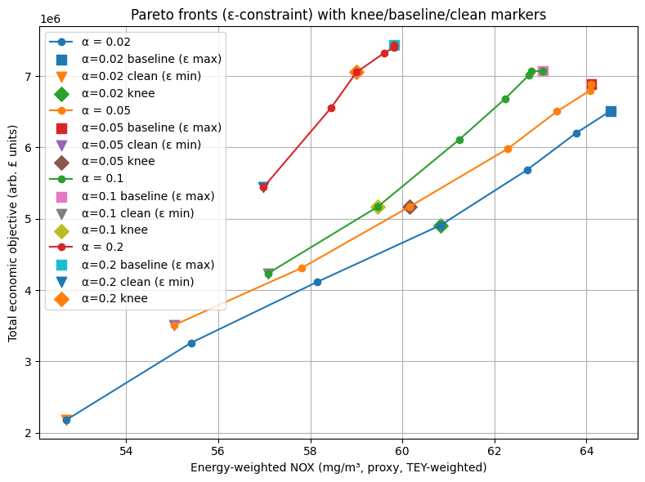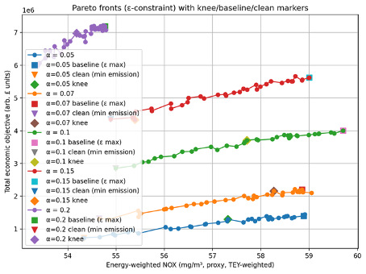
Figure 5 - Old CRC Implementation
Figure 6 - Improved CRC implementation

On the left (old implementation) we see the distribution frontiers are more overlapped, and sometimes hard to interpret as a clean hierarchy of risk. Higher risk settings can look too strong, and some curves partly dominate lower-α curve.
For example. The 0.2 frontier has a high economic value without a proportionate NOx penalty. In the improved implementation, the frontiers are more distinctly ordered by α. Lower α now clearly gives lower money and lower NOX. Higher α clearly buys back value. The whole family of curves is also shifted leftward in NOX space, especially at higher α, and the low-α frontiers are much more punitive in economic terms. The new implementation makes α correspond much more directly to the actual safety object the operators care about, which is an important tenet of this methodology.

Computation time

During development of the implementation, the high number of nested loops resulted in extensive runtimes per test if the models. This is due to the repeated closed loop simulations for every trajectory of the optimiser. This slows down debugging and testing as it reduces the rate at which results can be iterated. To solve this, a separate workflow was implemented defined as a fast development mode vs a final run. The code has explicit runtime controls through a separate set of variables that reduced many variables like the simulation set, TEY and LAMBDA grid size, and the number of trajectories. This means for the same data and the same saved surrogate artifacts, a lower resolution full result set can be run.

Another optimisation was reducing the need to rerun expensive steps that didn’t require rerunning to get results. Surrogate training and rebuilding the dataset features was implemented in a separate runtime and saved to hardware, such that they only needed to be run when changes had to be made for those specific features. This modularisation also had significant positive effects on computation time and general efficiency of development.

Results And Discussion

Description of Result Set
The results are presented in two parts. Initially it’s the surrogate training report. For each target, the exported results include the point model metrics by split, and quantile model metrics by split, with a conformal coverage profile across a and CRC classifier summary.

Second, the EMPC + CRC simulation produces a set of results over the risk array:

$$α∈0.05,0.07,0.10,0.15,0.20$$

The main risk-to-cash table records, for each α, total MWh, total economic objective, feasible and infeasible hours, feasible fraction, mean and standard deviation of TEY, realised per-pollutant breach rates, realised any-breach rate, and conformal violation rates. A separate e-constraint Pareto table reports, across α and NOX-cap values, mean simulated NOX, feasible-only NOX, economic objective, risk metrics, and feasibility metrics.

Key Result
Across the experiments, the main result is the idea that small changes in the risk gate can produce large changes in the existence and size of a feasible action set. In control terms, feasibility is a proxy for whether a dispatch algorithm can reliably keep the plant in an allowable envelope given model error. The practical implication is that, for ML-in-the-loop dispatch, the unit of analysis should be how error reshapes the feasible set and therefore the policy.

There is a clear general trend that more risk allowance results in higher economic objective, subject to certain modelling nuances. The results imply that with the available sensors on the test case, one pollutant is structurally harder to learn, and another is structurally harder to bound in the tails of its characteristic data. As previously described, NOx is strongly shaped by flame temperature, mixing, residence time, and control schedules that are not directly represented in the UCI sensor set. As a result, two hours with similar ambient conditions and TEY can correspond to different internal combustor states, so the mapping from available features to NOx is inherently noisy from the model’s perspective. CO is generally linked with transient operability constraints. These regimes often create heavy-tailed behaviour. Low-load and transient operation is explicitly stated in gas-turbine combustion references as a condition where emissions performance can change sharply due to control actions taken to preserve flame stability (Winkler Dieter and Geng, 2017).

This infers that when modelling these pollutants and targets, the strength of a target isn’t borne just from issues from modelling, but instead it is statistical signature of the nature of its derivation, and a sign that the dataset may be missing some of the causal variables that drive the formation of certain pollutants in the GT.

The evidence to support this is in the following sections.

Surrogate Model Point Accuracy

Point Model
The surrogate model was trained on a chronological split comprising of 25713 training rows, 5509 calibration rows and 5511 test rows. (appx B1)

See table B1 for full surrogate model accuracy results

The clearest result is that TIT is learned very accurately, whilst NOx is harder to predict, and CO is in between them, although having small absolute errors. ON the test set, the results are:

Target | MAE | RMSE | R² | sMAPE | Median Abs. Error | P90 Abs. Error | Interpretation
TIT | 2.15 | 2.94 | 0.976 | 0.20% | — | 4.86 | Learned very accurately
NOx | 3.91 | 5.13 | 0.625 | 6.82% | — | 7.72 | Weakest point; hardest target
CO | 0.456 | — | 0.731 | — | 0.276 | 0.905 | Moderate fit, small absolute errors
Table 1, Subset of Surrogate Model Accuracy
Full results in appendix B2

Empirically then, it can be said that the surrogate layer captures TIT very well, models CO moderately well in absolute terms, and it finds NOx to be the most difficult target to predict.
A nuance can be read from the test bias terms in the results. TIT has a mean error of -1.6, NOx is -3.03, and CO has a small positive bias of 0.2 (appx B2). Assuming the convention that

$e=y-\hat{y}$,

TIT and NOx are overpredicted whereas CO is underpredicted. This asymmetry is important because negative bias on constrained near limit variables or more concerning than a similar sized unbiased error because it can make high temp or high emission operating points appear safer than they are. This is why average fit measures like MAE are necessary for defining model usability (Hewamalage et al., 2023).

The relative behaviour of the point surrogates is consistent to how the quantities arise in heavy duty gas turbines and the operating regimes that the controller is bound by. TIT is a strongly actuated, thermodynamically governed variable. for a given machine, the firing/turbine-inlet temperature is tightly linked to fuel addition and compressor discharge conditions (and thus to load and ambient state), so it tends to vary smoothly and predictably under normal dispatch. This is consistent with the results.

Contrastingly, NOx fluctuations as a strong function of flame temperature and depends on residence time and oxygen content. In practical systems the flame structure can shift with pilot strategies and other unmeasured combustor variables (United States Department of Energy, 2022)
CO can spike at low load due to incomplete combustion and pilot fuel. Near zero CO also increases the percentage errors even when the MAE is small (Bender, n.d.).

Tail Accuracy and Uncertainty Calibration
Tail fidelity means how accurately a model captures the behaviour of a distribution – that is the most high or low outcomes.
The 4.2.1 results matter here because the upper bound construction is defined by the point prediction + correction, so any system point bias must be absorbed by the uncertainty to avoid overly optimistic bounds.

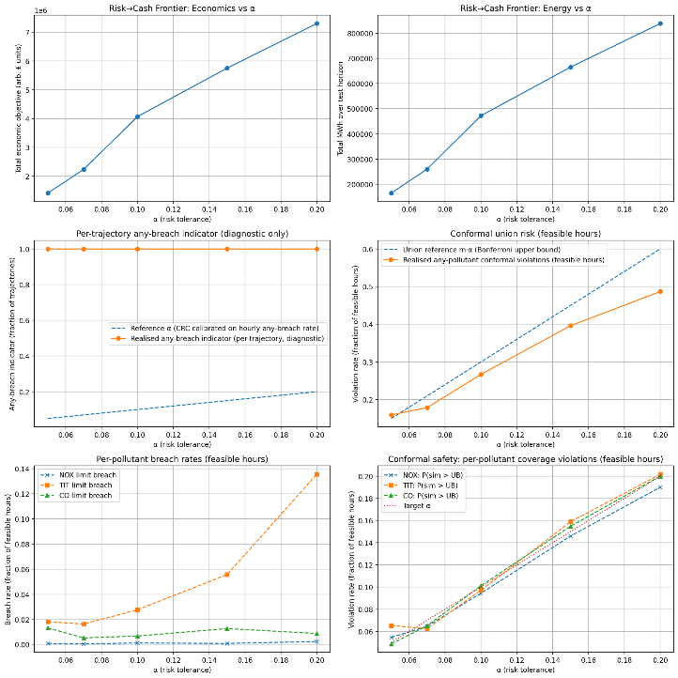
Figure 7 - CRC Risk Calibration and Closed-Loop Breach Diagnostics


Figure 8 - Risk–Cash Frontier Across α Risk Tolerances

With the raw upper quantile (τ = 0.95), the learned model over-covers TIT and NOX on test (TIT empirical coverage ≈ 0.983; NOX ≈ 0.988), but under-covers CO (empirical coverage ≈ 0.854; gap ≈ −0.096) (appx B3). If interpreting this literally, the CO quantile model is too low in the upper tail meaning it would understate risk if used as a direct safety bound. This is consistent with CO being the most heteroscedastic and heavy tailed target in the dataset summary.

The results show that the point-residual conformal is conservative across the α-grid (e.g., CO point coverage stays above nominal: at α=0.20, 0.8399 vs 0.80). However, the conformalised quantile regression, which is meant to adapt interval width to heteroscedasticity, still under-covers CO as α increases (CO CQR coverage falls to ≈ 0.672 at α=0.20; gap ≈ −0.128). By contrast, NOX and TIT CQR remain close to or above nominal at the same α values. This shows that adaptive CQR intervals can be less conservative than residual based conformalisation. For CO, that comes at the cost of insufficient tail buffer on the test set.

A plausible reason as to why CO has the hardest tail is that in gas turbines, CO rises quickly in low-temperature / low-load regimes where oxidation is incomplete. A gas-turbine handbook notes that under sustained low-load lean-premixed operation, CO emissions can increase significantly due to incomplete combustion and lower combustor temperatures (Bender, n.d.).

Simulation

CRC Risk Threshold and Closed Loop Risk Control
For each α, the code evaluates a grid of λ values over sampled trajectories and selects the largest λ whose corrected empirical risk satisfies the CRC criterion for the chosen loss. This distinction is important because the CRC is designed to control the expected value of a loss, not force the realised risk to equal a exactly at every operating point.

Full results in this section can be found in appendix B6

The results show that the CRC is economically consequential.
As α increases from 0.05 to 0.20, feasible operation rises from 1210/5511 hours (21.96%) to 5474/5511 hours (99.33%); total MWh increases from 164,692 to 838,758; and the total economic objective rises from about 1.42×10⁶ to 7.30×10⁶. , as seen in figure 3 below.

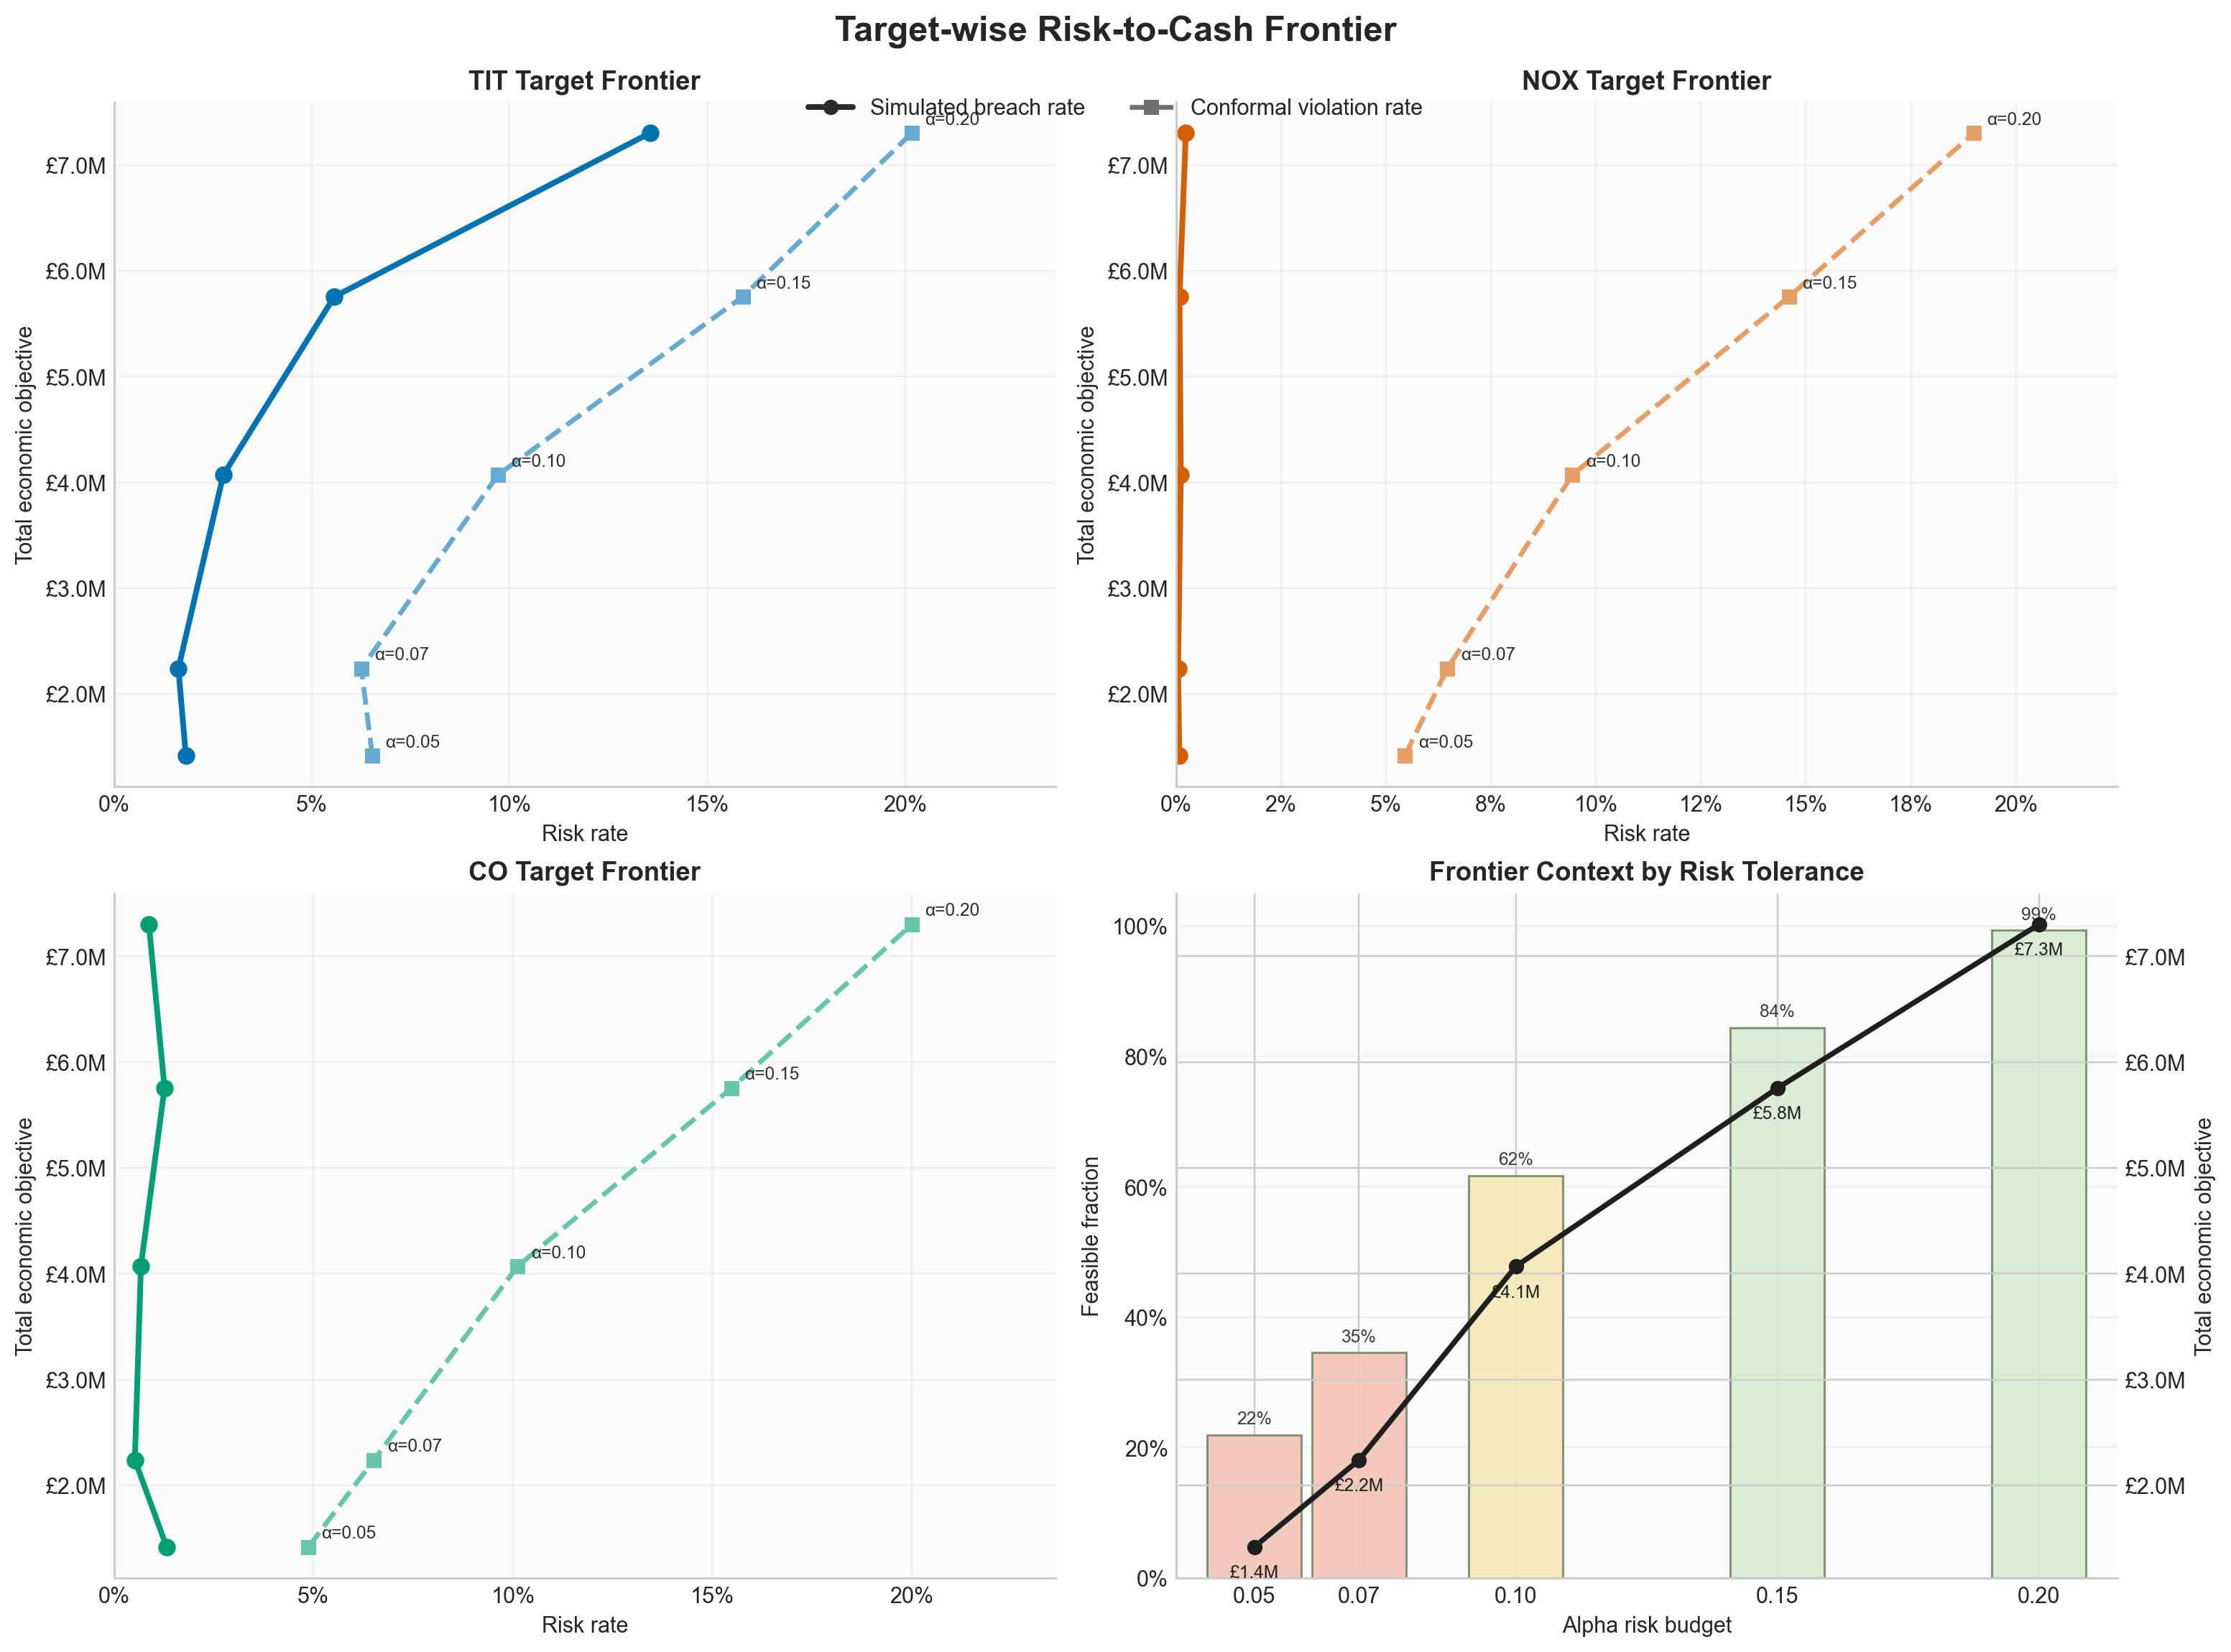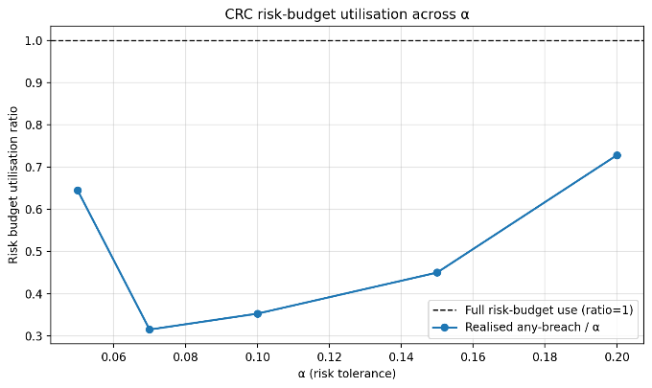
Figure 9 - Target-Wise Risk to Cash Frontier
Figure 10 - CRC risk-budget utilisation across alpha
At the same time, any breach rates stay below the target budget tested across the frontier: approximately 0.032, 0.022, 0.035, 0.068, 0.146 for α = 0.05, 0.07, 0.10, 0.15, 0.20.
This corresponds to a risk budget utilisation ratio of about 0.64, 0.32, 0.35, 0.45, 0.73.
It can be said that the CRC is conservative but works for its intended purpose. As α gets more lenient, more of the budget gets used, but is never saturated. This is to say allowing more risk lets the controller operate more often and earn more.

At α = 0.20, the breach rates are about 0.24% for NOX, 0.88% for CO, and 13.56% for TIT. This means that once the controller is allowed to operate more with more risk, the residual failures are mainly thermal instead of emission driven. This means that although the CRC is built to screen any breach, the frontier becomes mostly shaped by the TIT risk, increasingly as risk becomes more allowable.

It’s also important to separate the idea of constraint breaches to conformal upper bound violations. One is where the plant output exceeds the actual defined operational limit, but upper bound violation is where the output exceeds the predicted conformal upper bound for that hour.

At α = 0.20, the per-target conformal violation rates are close to the target α: about 0.190, 0.202, and 0.200. But the actual breach rates are much lower for NOX and CO. This suggests that the conformal upper bounds are acting as a buffer zone. Crossing an upper bound happens more often than crossing the hard safety limit itself. That is a reasonable outcome for a safety layer built from conformal prediction, where the purpose is calibrated protection.
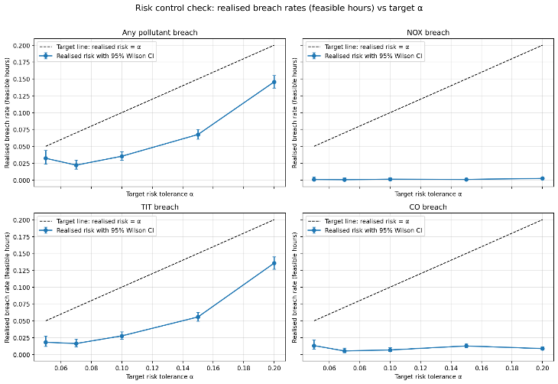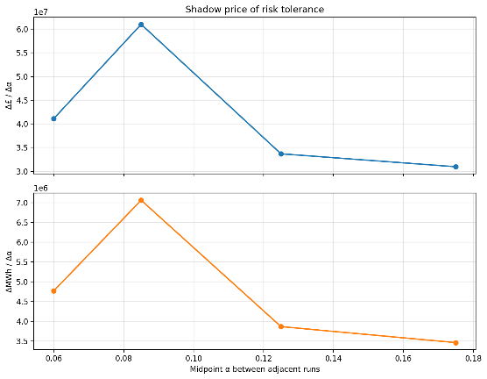
Figure 11 - Realised Breach rates vs target alpha
Figure 12 - Shadow Price of risk tolerance
It is important to interpret where exactly trade-off curve really changes, rather than whether it just generally rises. The risk-check plot (figure 5) uses 95% Wilson score intervals for the hourly breach rates, where Wilson intervals are way to put a confidence interval around a proportion or rate - such as the breach rate or fraction of hours with a violation, as seen in the figure above. If breaches were observed in say 40 out of 1000 hours, the Wilson score interval gives a plausible range for the true underlying breach probability.

In these results, the low a end is quite compressed. The hourly any-breach rates at α=0.05, 0.07 and 0.10 are 3.22%, 2.21% and 3.53%, and their Wilson intervals overlap enough that these three settings are not cleanly separated statistically. The higher settings, α=0.15 and 0.20, are much more clearly distinct. So, the main behavioural change happens once the controller moves out of the row risk region, rather than between every adjacent a.

A second point is that the operating points chosen by the controller become more concentrated as a increases. As seen in appx B6 and target-wise figure, the mean TEY rises from 29.88 to 152.2, however the standard deviation falls from 56.4 to 14.4. That means that while the controller accepts more hours, it’s also generally having higher output for these hours and more consistently allowing them. This is important in the wider context of power generation because gas turbines are most valuable when they can consistently hold stable high throughput operating regime rather than jump around power outputs.
These runs of the simulator are generated from the surrogate models + residuals, so this tighter TEY band over risk is evidence that the surrogates are internally consistent enough to support repeated selection of similar high-yield actions.

Figure 6 for shadow price of risk tolerance strengthens the perspective gained in these results.
Shadow price of risk tolerance is how much extra value is gained when the risk tolerance a is increased. It is essentially the derivative or slope of the risk-economy curve.

The marginal gain in objective per extra unit of α is highest between 0.07 and 0.10 at about 6.10×10⁷, then drops to 3.37×10⁷ between 0.10 and 0.15 and 3.10×10⁷ between 0.15 and 0.20. The same pattern appears for MWh. This means there is a knee (a point where the curve changes noticeably) around α≈0.10–0.15: beyond that point, extra tolerance still buys value, but each extra step yields less while thermal failures rise faster. In surrogate terms, that is the key finding: the models appear strong enough to unlock a better operating region, but under more aggressive control the TIT tail becomes the main limit on any more performance increases.

Pareto Frontier
As this is a problem with multiple criteria, as discussed before, the Pareto optimal set consists of solutions for which no objective can be improved without worsening at least one other objective. This is described as the pareto frontier.
Here, the optimised objective is the total economic value, and the constrained objective is the energy weighted NOx.
The energy weighting of NOx meaning the values in the simulated NOx series is averaged and weighted by the TEY, subject to the following equation:
$$\text{NO}{\text{x}}_{\text{energy-wtd }}=\frac{\sum_{t}{\text{NO}{\text{x}}_{\text{t}}}⋅\text{TE}{\text{Y}}_{\text{t}}}{\sum_{t}{\text{TE}{\text{Y}}_{\text{t}}}}$$

This is done because different implementations of the dispatch policy can differ in how much energy they produce and how often they are feasible, so it can be misleading to use absolute NOx values.

It is important to note that in these results, each e sweep is done under the risk tolerance parameter, so the true output is not a single frontier, but a set of frontiers indexed by the risk tolerance.

It is also noted that variable $e$ refers to the same Pareto e, and used in 2 different ways in the analysis.
- ε as the swept constraint parameter
- The achieved emissions value plotted on the Pareto axis.

The code does not multiply the ε limit by a scaling factor. Instead, it uses a separate tuning setting that changes how strongly the ε-sweep affects the results. This setting does three things: it changes the range of ε values tested, it changes the NOx rule used to accept or reject candidate actions, and it increases the weight placed on NOx in the objective during the Pareto sweep. So, this setting should be understood as a practical tuning control for the sweep, rather than as part of the standard ε-constraint method.

When talked about in the controller context, ε is implemented as an additional per-hour NOX cap in the closed-loop simulation: for each ε value you rerun EMPC+CRC “rejecting TEY candidates whose predicted NOX exceeds ε”.
In the results plots, when the scatter points are annotated ε=..., that is just stating the ε value used to generate that Pareto point (i.e., the cap parameter for that run).
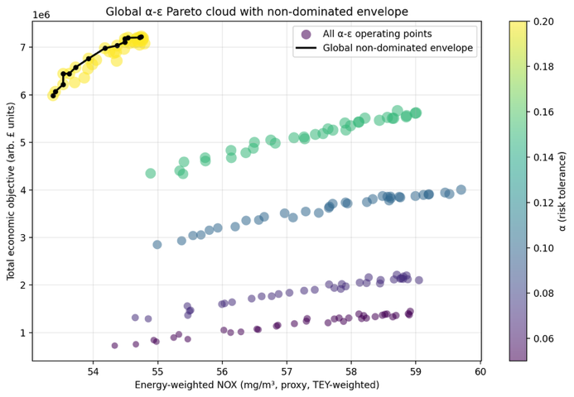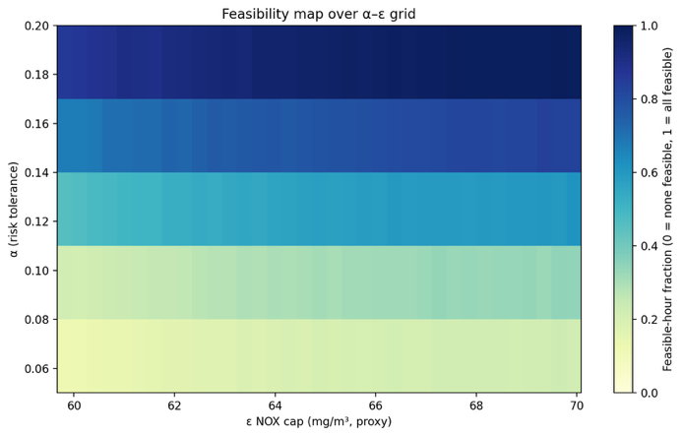
Figure 13 - Global alpha-epsilon pareto cloud with non dominated envelope
Figure 14 - Feasibility map over alpha - epsilon grid
Let us define the economic objective as $f$.
The figure above shows each band increasing in $f$ as NOx increases. Within each band of risk tolerance, the curve is positively sloped: larger NOx (looser ε since e is the right-hand side of an equality that caps the constrained objective) corresponds to larger $f$. This is the expected behaviour for an ε-constraint sweep where tightening emissions reduces the feasible set and reduces the seen values.

There is also a clear vertical separation between the risk tolerance levels in figure 7,
At low risk tolerance (α=0.05), points occupy roughly $f≈0.7\text{–}1.4×{10}^{6}$.
At high risk tolerance (α=0.20), points occupy roughly $f≈6.0\text{–}7.3×{10}^{6}$
This shows that risk tolerance is the primary driver of the achieved total value, rather than e alone, over the tested values.

It is also important to note that in figure 7, the α = 0.20 band has a low NOx (≈53–55 mg/m³) while also having higher value than lower-α bands. That means that a is changing which operating regimes are reachable under the risk constraints, making potentially more efficient decisions.

Figure 8 shows the fraction of feasible hours over the pareto sweep. The main effect is vertical gradient change where at α≈0.06–0.08, feasibility is low, and at α=0.20, feasibility is near full. Contrasting this, increasing ε at fixed α gives a smaller feasibility gain, for example along a =0.1, feasibility rises only slightly though the e values. This is consistent with the idea that α primarily determines if the controller finds feasible operation for a large portion of the horizon, whereas ε primarily determines where on the curve the feasible operation lands once feasibility is already considered.

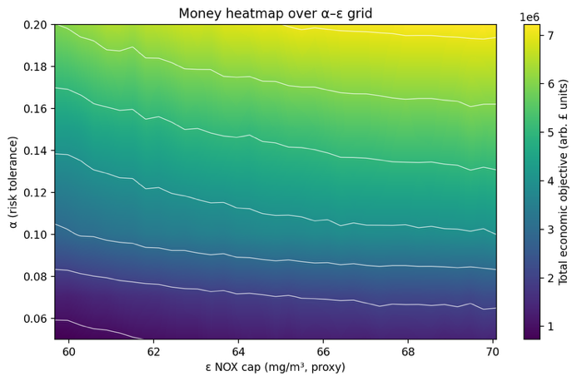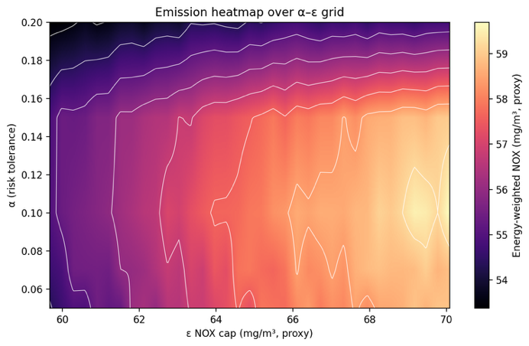
Figure 15 - Money heatmap over alpha-epsilon grid
Figure 16 - Emission heatmap over alpha-epsilon grid
Figure 9 is globally smooth and monotone, $f$ increases strongly with a and more mildly with e. The iso contours slope downwards, which infers that there’s a partial substitutability. A higher e can compensate (to some extent) for a stricter risk tolerance, but not fully in the context of this implementation. The emission heatmap shows that achieved energy-weighted NOx in roughly the 53–60 mg/m³ range. Achieved NOX rises with ε (as expected), but it also varies with α, implying that the risk controller changes operating regimes in a way that affects the realized emissions distribution.

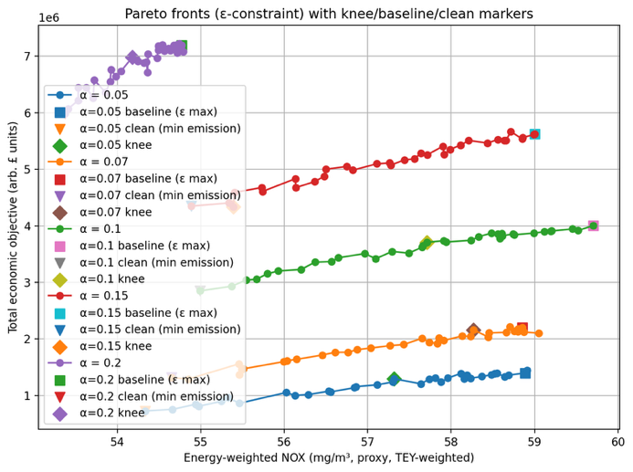
Figure 17 - Pareto Fronts with knee/baseline/clean markers
Knee points can make areas with high marginal utility obvious. These are areas where small gains in one objective would require disproportionately large sacrifices in the other (as previously mentioned).

In figure 11, for α=0.10 (green curve), the markers imply approximately:
- Baseline: NOX ≈ 59.7 mg/m³, $f≈4.0×{10}^{6}$.
- Clean: NOX ≈ 55.0 mg/m³, $f≈2.85×{10}^{6}$.
- Knee: NOX ≈ 57.7 mg/m³, $f≈3.7×{10}^{6}$.
This implies a trade-off:
- Baseline → Clean: abatement $ΔE≈4.7$mg/m³ for value loss $Δf≈1.15×{10}^{6}$.
- Baseline → Knee: abatement $ΔE≈2.0$mg/m³ for value loss $Δf≈0.3×{10}^{6}$.
This is to say that the knee point captures ~43% of the abatement for ~26% of the value loss, which is a mechanism that is useful when optimising the controller to search for points of maximum interest and value to an operator.

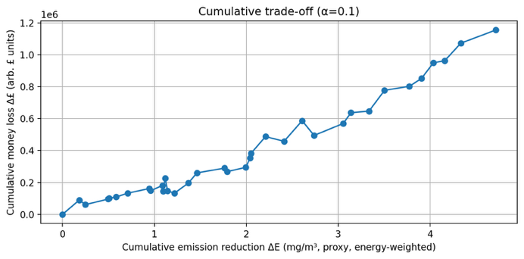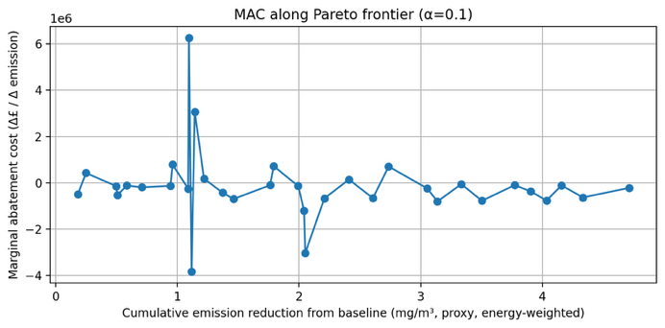
Figure 18 - Cumulative trade-off at alpha = 0.1
Figure 19 - MAC along Pareto frontier at alpha = 0.1
The figure 12, cumulative trade at a= 0.10 continues to reinforce the same evidence, that cumulative money loss $Δf$increases to ~$1.15×{10}^{6}$ as cumulative NOX reduction $ΔE$ reaches ~4.7 mg/m³, with smaller local areas non-monatomicities. This could be due to

(i) simulation noise and finite-sample estimation: each frontier point is based on a single closed-loop simulated rollout, so small random differences in realised outcomes can make neighbouring ε points swap order slightly. This is a standard issue in simulation-based optimisation unless you average over multiple replications (Kim et al., 2011) .
(ii) finite-difference amplification in MAC: your MAC curve is computed from adjacent-point ratios $Δf/ΔE$, so when two neighbouring points have very small $ΔE$, even tiny noise in $f$produces large spikes or sign flips. Finite-difference derivatives are well known to be unstable under noisy function evaluations. This is the likely cause the outlier in the figure below (Kim et al., 2011).

Figure 13 estimates the marginal abatement cost $\left(Δf/ΔE\right)$ . In literature, the MAC (marginal abatement cost) is a defined as the cost associated with the last unit of abatement for varying amounts of abatement. The plot shows sharp spikes in positive and negative directions around ΔE≈1.1 mg/m³, which implies that adjacent sampled points sometimes change 𝑓 and NOx in inconsistent directions. This alone doesn’t necessary render the analyse invalid, but it does show that the local slope estimates are sensitive to discretization and simulation noise. Literature explores this and cautions against over-interpreting curve details (Kesicki and Ekins, 2012).

The Wider Context

Interpretation of results
The main value of the method is that it protects decision-making under uncertainty. In a constrained controller, performance depends on how many actions are still allowed after the safety and emissions checks are applied. When the uncertainty margin changes, that feasible set can change quickly. A small statistical change can therefore create a large operational change. This is consistent with how constrained predictive control works, where different active constraints create different decision regions, and with the wider idea of a safe operating envelope.

This gives a more useful reading of the risk–value trade-off in this dissertation. At first, relaxing the risk setting gives the controller back real freedom. More actions remain feasible, so the plant can use a wider and more valuable part of its operating range. After that, the gains become smaller. The controller is mostly choosing between similar actions, while the same hard limit still dominates. In that sense, CRC is a practical way to manage the safe operating envelope of the plant.

This interpretation is useful because it changes how the method should be tuned. The main concern becomes also how much operating freedom remains after the uncertainty margin is applied. In practice, that means the method should be judged using measures such as the number of feasible candidate actions, the spread of accepted actions, and which constraint is active most often. Those measures would show whether the controller is still making meaningful choices, or whether it has become safe mainly by removing too much of the operating space.

Operational Translation of Variables
For translating the methodology to other contexts, it must be understood that the risk is a frequency of adverse events under the decision maker. This is what would be considered the main transferable conceptual element.

In an industrial setting, the operator often acts a risk manager of an operating envelope. They decide how close the plant runs to defined limits, how much to tolerate overruns, and what operation matters for compliance etc (Senthilvelan et al., 2025a).
In the implementation ‘cash’ or ‘economy’ is a placeholder proxy for economic utility. It is the quantity traded off against constraint risk. To generalise to other deployments, operators can reinterpret the objective as any operation value function that the organisation recognises and care abouts. This could be profit, fuel cost, carbon cost, availability value etc. Real world optimization is often similarly framed as maximising operation profit due to changing conditions and constraints (Eker and Taware, 2003).
A transfer is the comparative idea that increasing tolerance for constraint risk expands the reachable operating region, but with diminishing marginal returns beyond a knee. The results of the project already quantify the knee for the setup, but an operator in a different plant could reuses the interpretation where spending more of a predefined budget may yield less value because another constraint or failure mode becomes binding.

In the project, feasibility is the existence of at least on candidate action that passes the constraint checks at each time step. In terms of a real-world operator, this can be interpreted as the operation headroom. A high feasible fraction means the current policies still leave the plan room to make more decisive decisions, and a low feasible fraction means the constraint set is incompatible with the target region given the disturbances and modelling error.
Conceptually, this alignment matches how safe operating limits are treated in safety processes, where limits define an allowable operating region, and a policy is derived that leaves a margin, so disturbances don’t cause failures (Senthilvelan et al., 2025b).

The results already show a generalisable pattern that feasibility is governed by risk tolerance, and change a fixed parameter e at fixed a has smaller feasibility gains. This could be interpreted by an operator as the risk tolerance controls whether the controller can reliable find admissible operating regions across the horizon, while e selects which admissible regime is chosen once admissibility is common and acceptable.
The results show how an operator can reason with the risk tolerance. The knee around a = 0.1 – 0.15 indicates a point where relaxing risk tolerance yields diminishing marginal value and rising thermal-limit issues. In another plant, the knee might occur elsewhere and might be driven by different constraints. The logic however remains the same.

In terms of the interpretability of the CRC threshold (considered λ), it is a threshold based on a risk score so that the empirical risk of a chosen loss stays below a in expectation.
In operator terms, λ could generalise into a boundary used in screening, where actions with sufficiently high predicted risk are excluded from consideration. Due to the fact the CRC is explicitly designed to be meaningful under certain types of distribution shift, λ can also be read as a closed loop robustness variable as it is calibrated on trajectories that reflect the policies behaviour. This is recognised issue in performative prediction where changing targets induce a shift in operation (J. Perdomo et al., 2020).

The “learned safety margin” of the conformal prediction is especially relevant for emissions because real emissions monitoring and compliance checking explicitly deal with measurement uncertainty and instrument drift/quality assurance. Guidance documents describe how uncertainty is assessed and how compliance against emission limit values (ELVs) should account for it. The conformal margin can be interpreted as a data-driven analogue of the uncertainty buffer that compliance frameworks already recognise (Environment Agency and United Kingdom Government, 2025).

Failure Modes and Shortcomings
It could be said that some patterns in the results set are driven by the decision-making process as much as the actual turbine behaviour. The controller never optimises over a smooth region, it’s always a discrete grid of TEY options, that is reduced by set of filters. This means small changes in modelling or calibration can likely produce large changes in the number of feasible hours and in turn the performance of the turbine.

A major shortcoming of this implementation of the methodology is how conservative the model can be from the stacking of the safety layers. Conformal bounds already widen predictions to prevent against errors in the tails, and then CRC could reject them again based on its own learned criteria. When these layers overlap, the feasible set can shrink for reasons that aren’t based on true operational choices, but just through the construction of the method.
If a single blocker dominates the regime, then the frontier can be more representative of the methodological choices rather than the relationship you’re really looking for.

The CRC introduces another failure mode. It relies on the ranking quality of the risk score more than on real probabilities. If exceedances of these values are, rare, the breach classifiers can rank near boundary cases poorly. This matters because the optimiser tends to operate near constraints. If this is the case, then a may not translate cleanly into different realised risk levels even if the calibration is correct.

Another shortcoming of the method comes from the simulation. The closed loop process adds residuals per target the resampled independently. This can make cross target dependence lose value and reduce the effect of temporal persistence, which can negatively affect results.

Conclusion

The project shows that managing uncertainty alters the feasible action set of gas turbine operation, thus changing the operation policy and value. In this context, conformal bounds and the CRC gate played an important role, as they determined the potential for economically viable dispatch.

As risk tolerance increased, both feasibility and economic value increased, but these gains were not linear.
A noticeable point emerged around α ≈ 0.10–0.15. Beyond this, taking on more risk yielded diminishing returns while the likelihood of thermal failures grew rapidly. This indicates that TIT, rather than emissions alone, became the primary limiting factor.
Furthermore, the results suggest that average prediction accuracy isn't enough to evaluate models ready for control. While TIT was the easiest to learn, NOx proved structurally hard to predict, and CO was the most difficult to reliably bound at high levels. However, closed-loop performance hinged more on behaviour near constraint boundaries than on overall error metrics.

These findings should be approached critically. The described issues such as using proxy economics, proxy limits, and a limited scope dataset means that the results are not necessarily generalisable.

This work could be improved if it could be tested under broader evidence base; such as a larger dataset or data from different turbines in different environments rather than relying on a single dataset. Future work should model the dependence between TIT, NOx and CO more explicitly, because the current target-wise surrogates and breach models only capture this indirectly, and CO was the hardest variable to bound reliably in the upper tail. The work could be extended to work with different surrogate models and NN’s and could also be introduced into a live setting where new data is sequentially added during operation to explore findings in that space.

Bibliography

Ames Research Staff, B., Field, M., n.d. EQUATIONS, TABLES, AND CHARTS FOR COMPRESSIBLE FLOW.
Angelopoulos, A.N., Bates, S., 2022. A Gentle Introduction to Conformal Prediction and Distribution-Free Uncertainty Quantification.
Angelopoulos, A.N., Bates, S., Fisch, A., Lei, L., Schuster, T., 2025. Conformal Risk Control.
Arrigo, A., Ordoudis, C., Kazempour, J., De Grève, Z., Toubeau, J.F., Vallée, F., 2022. Wasserstein distributionally robust chance-constrained optimization for energy and reserve dispatch: An exact and physically-bounded formulation. Eur. J. Oper. Res. 296, 304–322. https://doi.org/10.1016/j.ejor.2021.04.015
Asif, M., Amin, A., Jamil, U., Mahmood, A., Ahmed, U., Razzaq, S., Mahdi, F.P., 2024. Combined emission economic dispatch using quantum-inspired particle swarm optimization and its variants. Energy Exploration and Exploitation 42, 1602–1644. https://doi.org/10.1177/01445987241235419
Bender, Wi.R., n.d. 3.2.1.2 Lean Pre-Mixed Combustion 3.2.1.2-1 Introduction 3.2.1.2-2 Emissions Overview.
Clarke, D.R., Levi, C.G., 2003. Materials Design for the Next Generation Thermal Barrier Coatings. Annu. Rev. Mater. Res. 33, 383–417. https://doi.org/10.1146/annurev.matsci.33.011403.113718
Collins, G.S., Moons, K.G.M., Dhiman, P., Riley, R.D., Beam, A.L., Van Calster, B., Ghassemi, M., Liu, X., Reitsma, J.B., Van Smeden, M., Boulesteix, A.L., Camaradou, J.C., Celi, L.A., Denaxas, S., Denniston, A.K., Glocker, B., Golub, R.M., Harvey, H., Heinze, G., Hoffman, M.M., Kengne, A.P., Lam, E., Lee, N., Loder, E.W., Maier-Hein, L., Mateen, B.A., McCradden, M.D., Oakden-Rayner, L., Ordish, J., Parnell, R., Rose, S., Singh, K., Wynants, L., Logullo, P., 2024. TRIPOD+AI statement: Updated guidance for reporting clinical prediction models that use regression or machine learning methods. BMJ. https://doi.org/10.1136/bmj-2023-078378
Dixit, A., Lindemann, L., Wei, S.X., Cleaveland, M., Pappas, G.J., Burdick, J.W., 2023. Adaptive Conformal Prediction for Motion Planning among Dynamic Agents, in: Matni, N., Morari, M., Pappas, G.J. (Eds.), Proceedings of The 5th Annual Learning for Dynamics and Control Conference, Proceedings of Machine Learning Research. PMLR, pp. 300–314.
dos Santos Coelho, L., Hultmann Ayala, H.V., Cocco Mariani, V., 2024a. CO and NOx emissions prediction in gas turbine using a novel modeling pipeline based on the combination of deep forest regressor and feature engineering. Fuel 355. https://doi.org/10.1016/j.fuel.2023.129366
dos Santos Coelho, L., Hultmann Ayala, H.V., Cocco Mariani, V., 2024b. CO and NOx emissions prediction in gas turbine using a novel modeling pipeline based on the combination of deep forest regressor and feature engineering. Fuel 355, 129366. https://doi.org/10.1016/j.fuel.2023.129366
Efron, B., 1979. Bootstrap Methods: Another Look at the Jackknife.
Eker, S.A., Taware, A., 2003. REAL-TIME OPTIMAL OPERATION DECISIONS FOR GAS TURBINES.
Enviroment Agency, United Kingdom Government, 2025. Monitoring stack emissions: quality assurance of continuous monitoring [WWW Document]. GOV.UK.
Fontana, M., Zeni, G., Vantini, S., 2023. Conformal prediction: A unified review of theory and new challenges. Bernoulli 29, 1–23. https://doi.org/10.3150/21-BEJ1447
Förtsch, D., 2025. On the dependencies of the average specific heat capacity of flue gas. Fuel Communications 23, 100136. https://doi.org/10.1016/j.jfueco.2025.100136
Foygel Barber, R., Candès, E.J., Ramdas, A., Tibshirani, R.J., 2021. The limits of distribution-free conditional predictive inference. Information and Inference 10, 455–482. https://doi.org/10.1093/imaiai/iaaa017
Freedman, D.A., 1981. Bootstrapping Regression Models, Source: The Annals of Statistics.
Gibbs, I., Candès, E., 2021. Adaptive Conformal Inference Under Distribution Shift.
Grinsztajn, L., Oyallon, E., Varoquaux, G., 2022. Why do tree-based models still outperform deep learning on tabular data?
Hewamalage, H., Ackermann, K., Bergmeir, C., 2023. Forecast evaluation for data scientists: common pitfalls and best practices. Data Min. Knowl. Discov. 37, 788–832. https://doi.org/10.1007/s10618-022-00894-5
Hu, Y., Li, Y., Xu, M., Zhou, L., Cui, M., 2017. A chance-constrained economic dispatch model in wind-thermal-energy storage system. Energies (Basel). 10. https://doi.org/10.3390/en10030326
Jhinaoui, A., Malkogianni, A., City, M., Dhabi, A., Hasani Azamar, U., Tsoutsanis, E., n.d. ATTENTIONAL NEURAL NETWORK FOR THE PREDICTION OF GAS TURBINE CO AND NOx EMISSION.
Jhinaoui, A., Malkogianni, A., City, M., Dhabi, A., Hasani Azamar, U., Tsoutsanis, E., n.d. ATTENTIONAL NEURAL NETWORK FOR THE PREDICTION OF GAS TURBINE CO AND NOx EMISSION.
Ke, G., Meng, Q., Finley, T., Wang, T., Chen, W., Ma, W., Ye, Q., Liu, T.-Y., n.d. LightGBM: A Highly Efficient Gradient Boosting Decision Tree.
Kesicki, F., Ekins, P., 2012. Marginal abatement cost curves: a call for caution. Climate Policy 12, 219–236. https://doi.org/10.1080/14693062.2011.582347
Kesicki, F., Strachan, N., 2011. Marginal abatement cost (MAC) curves: confronting theory and practice. Environ. Sci. Policy 14, 1195–1204. https://doi.org/10.1016/j.envsci.2011.08.004
Kim, S., Pasupathy, R., Henderson, S.G., 2011. A Guide to Sample-Average Approximation.
Lei, J., G’sell, M., Rinaldo, A., Tibshirani, R.J., Wasserman, L., n.d. Distribution-Free Predictive Inference for Regression.
Lindemann, L., Cleaveland, M., Shim, G., Pappas, G.J., 2023a. Safe Planning in Dynamic Environments using Conformal Prediction.
Lindemann, L., Cleaveland, M., Shim, G., Pappas, G.J., 2023b. Safe Planning in Dynamic Environments Using Conformal Prediction. IEEE Robot. Autom. Lett. 8, 5116–5123. https://doi.org/10.1109/LRA.2023.3292071
Lipperheide, M., Gassner, M., Weidner, F., Bernero, S., Wirsum, M., 2018. Long-term carbon monoxide emission behavior of heavy-duty gas turbines: An approach for model-based monitoring and diagnostics. International Journal of Spray and Combustion Dynamics 11. https://doi.org/10.1177/1756827718791921
Marouani, I., Guesmi, T., Abdallah, H.H., Alshammari, B.M., Alqunun, K., Alshammari, A.S., Rahmani, S., 2022. Combined Economic Emission Dispatch with and without Consideration of PV and Wind Energy by Using Various Optimization Techniques: A Review. Energies (Basel). https://doi.org/10.3390/en15124472
Mavrotas, G., 2009. Effective implementation of the ε-constraint method in Multi-Objective Mathematical Programming problems. Appl. Math. Comput. 213, 455–465. https://doi.org/10.1016/j.amc.2009.03.037
Mcbride, B.J., Zehe, M.J., Gordon, S., 2002. NASA Glenn Coefficients for Calculating Thermodynamic Properties of Individual Species.
Pachauri, N., 2024. An emission predictive system for CO and NOx from gas turbine based on ensemble machine learning approach. Fuel 366, 131421. https://doi.org/10.1016/j.fuel.2024.131421
Perdomo, J., Zrnic, T., Mendler-Dünner, C., Hardt, M., 2020. Performative Prediction, in: III, H.D., Singh, A. (Eds.), Proceedings of the 37th International Conference on Machine Learning, Proceedings of Machine Learning Research. PMLR, pp. 7599–7609.
Perdomo, J.C., Zrnic, T., Mendler-D ¨, C., Hardt, M., 2020. Performative Prediction.
Potts, R., Hackney, R., Leontidis, G., 2023. Tabular Machine Learning Methods for Predicting Gas Turbine Emissions. Mach. Learn. Knowl. Extr. 5, 1055–1075. https://doi.org/10.3390/make5030055
Richards, G., Weiland, N., Strakey, P., n.d. Combustion Strategies for Syngas and High-Hydrogen Fuel.
Romano, Y., Patterson, E., Candès, E.J., n.d. Conformalized Quantile Regression.
Saravanamuttoo, H.I.H.., 2017. Gas turbine theory. Pearson.
Senthilvelan, K., Shaik, S.M., Wong, W.C., Sugiman, D., 2025a. From theory to practice: Implementing safe operating limits in major hazard facilities. Process Safety Progress 44, 553–563. https://doi.org/10.1002/prs.70031
Senthilvelan, K., Shaik, S.M., Wong, W.C., Sugiman, D., 2025b. From theory to practice: Implementing safe operating limits in major hazard facilities. Process Safety Progress 44, 553–563. https://doi.org/10.1002/prs.70031
Shafer, G., Vovk, V., 2008. A Tutorial on Conformal Prediction, Journal of Machine Learning Research.
Tibshirani, R.J., Barber, R.F., Candès, E.J., Ramdas, A., 2019. Conformal prediction under covariate shift, in: Proceedings of the 33rd International Conference on Neural Information Processing Systems. Curran Associates Inc., Red Hook, NY, USA.
UCI Machine Learning Repository, 2019. Gas Turbine CO and NOx Emission Data Set.
United States Department of Energy, 2022. A LITERATURE REVIEW OF HYDROGEN AND NATURAL GAS TURBINES: CURRENT STATE OF THE ART WITH REGARD TO PERFORMANCE AND NO X CONTROL A LITERATURE REVIEW OF HYDROGEN AND NATURAL GAS TURBINES: CURRENT STATE OF THE ART WITH REGARD TO PERFORMANCE AND NOX CONTROL 1.
United States Environmental Protection Agency, 2025a. Nitrogen Dioxide (NO2) Pollution [WWW Document]. https://www.epa.gov/no2-pollution/basic-information-about-no2?utm_source=chatgpt.com.
United States Environmental Protection Agency, 2025b. Carbon Monoxide (CO) Pollution in Outdoor Air [WWW Document]. https://www.epa.gov/co-pollution/basic-information-about-carbon-monoxide-co-outdoor-air-pollution?utm_source=chatgpt.com.
Unnikrishnan, U., Yang, V., 2022. A review of cooling technologies for high temperature rotating components in gas turbine. Propulsion and Power Research. https://doi.org/10.1016/j.jppr.2022.07.001
Winkler Dieter and Geng, W. and E.G. and S.P. and K.K. and G.T., 2017. Staged combustion concept for gas turbines. Journal of the Global Power and Propulsion Society 1, 184–194. https://doi.org/10.22261/CVLCX0
Xu, C., Xie, Y., 2021. Conformal Prediction Interval for Dynamic Time-Series.
Yang, Y., Nikolaidis, T., Jafari, S., Pilidis, P., 2024. Gas turbine engine transient performance and heat transfer effect modelling: A comprehensive review, research challenges, and exploring the future. Appl. Therm. Eng. 236, 121523. https://doi.org/10.1016/j.applthermaleng.2023.121523

Appendices

A: Pseudocode summary of main algorithms used in codebase

A1 – Surrogate model training

ALGORITHM train_surrogates():

// ── Load pre-built feature artifact (written by surrogate_model.py) ──
prepared ← load_prepared_feature_artifact(PREPARED_FEATURES_PATH)
df ← prepared['df']
X ← prepared['X'] // full feature matrix
m_train ← prepared['mask_train'] // bool mask, 70% of rows
m_calib ← prepared['mask_calib'] // bool mask, 15% of rows
target_feature_map ← prepared['target_feature_map']
// {TIT: [...], NOX: [...], CO: [...]}
// TIT: base_exog + time_feats + lag1 of {TEY,TIT,GTEP,TAT,CDP}
// NOX: TIT features + NOX history lags {1,2,3}
// CO : NOX features + CO history lags {1,2,3,6,12,24}

// ── Leakage guard ─────────────────────────────────────────────────────
assert {TIT, TAT, GTEP, CDP} ∩ features = ∅ // current-step outputs excluded
assert TIT_lag1 ∈ target_feature_map['TIT']
assert NOX_lag1 ∈ target_feature_map['NOX']
assert CO_lag1 ∈ target_feature_map['CO']

X_train ← X[m_train]; X_calib ← X[m_calib]

for target in {TIT, NOX, CO}:

feats ← target_feature_map[target]
X_tr_all ← X_train[feats] // target-specific columns only
y_tr_all ← df[target][m_train]

// Inner temporal validation split (last 10% of train, min 200 rows)
n_val ← max(200, floor(0.10 × len(X_tr_all)))
X_tr, X_val ← X_tr_all[: −n_val], X_tr_all[−n_val :]
y_tr, y_val ← y_tr_all[: −n_val], y_tr_all[−n_val :]

// Point model – L1 (MAE) objective
point_model ← LGBMRegressor(
objective='regression', n_estimators=5000, learning_rate=0.03,
num_leaves=96, feature_fraction=0.9, bagging_fraction=0.9,
bagging_freq=1, min_data_in_leaf=120, max_bin=255)
point_model.fit(X_tr, y_tr,
eval_set=[(X_val, y_val)], eval_metric='l1',
callbacks=[early_stopping(100), log_evaluation(50)])

// Upper-quantile model – pinball loss at τ = 0.95
quant_model ← LGBMRegressor(
objective='quantile', alpha=0.95, …same hyper-params…)
quant_model.fit(X_tr, y_tr,
eval_set=[(X_val, y_val)], eval_metric='quantile',
callbacks=[early_stopping(100), log_evaluation(50)])

// Calibration residuals for conformal step (Algorithm 2)
yhat_calib ← point_model.predict(X_calib[feats])
calib_residuals ← df[target][m_calib] − yhat_calib // signed residuals

// Save artefacts
save(point_model) → surrogate_models/{target}/point_regressor.joblib
save(quant_model) → surrogate_models/{target}/upper_quantile_regressor_tau0.95.joblib
save(calib_residuals) → surrogate_models/{target}/calibration_residuals.npy
log calib MAE, R²

write surrogate_training_manifest.json

A2 – Build conformal bounds and train CRC breach classifiers

Part A — Conformal Bounds

ALGORITHM build_conformal_bounds():

// Uses the calibration residuals saved by Algorithm 1
for target in {TIT, NOX, CO}:

point_model ← load(surrogate_models/{target}/point_regressor.joblib)
quant_model ← load(surrogate_models/{target}/upper_quantile_regressor_tau0.95.joblib)
residuals ← load(surrogate_models/{target}/calibration_residuals.npy)
// residuals = y_calib − yhat_calib (signed, n_calib values)

// For each miscoverage level α in ALPHAS = [0.05, 0.07, 0.10, 0.15, 0.20]:
for α in ALPHAS:

// ── Split-conformal upper quantile ─────────────────────────────
res_sorted ← sort(residuals) // ascending
k ← ceil((n_calib + 1) × (1 − α)) // finite-sample correction
k ← clip(k, 1, n_calib)
q_point[α] ← res_sorted[k − 1] // scalar added to yhat at test time
// Guarantee: P(y_true ≤ yhat + q_point) ≥ 1 − α

// ── CQR (Conformalized Quantile Regression) score ──────────────
// score_i = y_calib_i − qhat_calib_i (exceedance above τ=0.95 quantile pred)
score_calib ← y_calib[target] − quant_model.predict(X_calib)
q_cqr[α] ← conformal_upper_quantile(score_calib, α) // same procedure as above

// Verify test coverage for reporting
yhat_test ← point_model.predict(X_test[feats])
for α in ALPHAS:
cov_point ← mean(y_test[target] ≤ yhat_test + q_point[α])
cov_cqr ← mean(y_test[target] ≤ quant_model.predict(X_test) + q_cqr[α])
record coverage and gap (cov − (1−α))

save conformal_bounds_summary.json
// Stored fields per target:
// point_residual_quantiles : list of q_point values, one per α
// cqr_score_quantiles : list of q_cqr values, one per α
// point_test_coverage : empirical coverage check on test split

Part B — CRC Breach-Probability Classifiers

ALGORITHM train_crc_breach_classifiers():

train_df ← df[m_train]
X_train ← X[m_train]
X_calib ← X[m_calib]

// Proxy limits = 95th percentile of each target on the TRAINING split
proxy_limit[NOX] ← quantile(train_df['NOX'], 0.95)
proxy_limit[TIT] ← quantile(train_df['TIT'], 0.95)
proxy_limit[CO] ← quantile(train_df['CO'], 0.95)

for target in {TIT, NOX, CO}:

// Binary label: did the true value exceed the proxy limit?
breach_label ← (train_df[target] > proxy_limit[target]).astype(int)
// positive class = high-emissions / high-TIT operating point

feats ← target_feature_map[target]
clf ← LGBMClassifier(
n_estimators=200, learning_rate=0.05, num_leaves=63,
feature_fraction=0.8, bagging_fraction=0.8, bagging_freq=1,
min_data_in_leaf=60, max_bin=255)
clf.fit(X_train[feats], breach_label) // no early stopping; fixed 200 trees

// Diagnostic: score distribution on calib set
calib_scores ← clf.predict_proba(X_calib[feats])[:, 1]
log train_prevalence, calib_score_mean, calib_score_std

save clf → crc_classifiers/{target}_breach_probability_classifier.joblib

write crc_classifier_manifest.json
// These classifiers supply breach scores to Algorithm 3 (CRC calibration)
// and to Algorithm 4 (hourly EMPC optimisation).

Part C – Calibrate CRC threshold

ALGORITHM calibrate_crc_threshold_any_full(
α, trajectories, init_rows, lambda_grid,
limit_NOX, limit_TIT, limit_CO,
point_models, conformal_quantiles, residuals_map,
breach_clfs, tey_candidates, feature_pos, alpha_idx_map,
loss_mode, monotone=True):

// Inputs
// trajectories : list of n_traj DataFrames, each CRC_TRAJECTORY_HOURS rows
// drawn i.i.d. with replacement from the calibration split
// init_rows : matching list of seed rows (from training split) used to
// initialise lagged state at the start of each trajectory
// lambda_grid : 1-D array of candidate λ values, built from quantiles of
// the any-breach score on the calib set (size CRC_LAMBDA_GRID_SIZE)
// loss_mode : 'any_breach_rate' → fraction of feasible hours with
// any breach within a trajectory
// 'any_breach_indicator' → 1 if any breach occurred anywhere

n_traj ← len(trajectories)
n_lambda ← len(lambda_grid)
losses ← zeros(n_traj × n_lambda) // one loss value per (trajectory, λ)

for t_idx in 0 … n_traj − 1:
traj_df ← trajectories[t_idx] // simulated exogenous conditions
init_row ← init_rows[t_idx] // lagged-state seed
rng_t ← RNG seeded from (base_seed + t_idx × 10007)

for l_idx, λ in enumerate(lambda_grid):

// Temporarily set the any-breach CRC gate to λ
crc_thresholds_tmp ← {'ANY': {α: λ}}

// Run a full receding-horizon EMPC rollout on this trajectory
sim_df ← _simulate_empc_core(
α, X_dummy=DataFrame(index=traj_df.index),
limits, point_models, conformal_quantiles,
df_full=traj_df, m_calib=None,
residuals_map, breach_clfs,
crc_thresholds=crc_thresholds_tmp,
tey_candidates, feature_pos, alpha_idx_map,
epsilon_nox=None, init_row=init_row, rng=rng_t)
// see Algorithm 4 for _simulate_empc_core internals

// Evaluate trajectory loss
feasible_mask ← sim_df['sim_TIT'].notna()
if mode == 'any_breach_rate':
any_breach ← sim_df[feasible_mask]
.any(axis=1, cols=['sim_nox_breach','sim_tit_breach','sim_co_breach'])
losses[t,l] ← mean(any_breach) // fraction of feasible hours breached
elif mode == 'any_breach_indicator':
losses[t,l] ← 1 if any breach occurred else 0

// ── Monotone correction ────────────────────────────────────────────────
// A smaller λ (more conservative gate) should never produce MORE breaches
// than a larger λ; enforce this by taking the running maximum left-to-right.
if monotone:
losses ← cumulative_max(losses, axis=lambda_dim) // shape unchanged

// ── Finite-sample CRC selection rule ──────────────────────────────────
mean_loss ← column_mean(losses) // shape: (n_lambda,)
corrected ← (1 + n_traj × mean_loss) / (n_traj + 1)
// corrected[l] ≤ α ⟺ λ_l satisfies the CRC coverage guarantee at level α

valid ← indices where corrected ≤ α
if valid not empty:
λ* ← lambda_grid[ valid[-1] ] // largest λ still guaranteed
else:
λ* ← lambda_grid[0] // most conservative fallback

return λ*

// Called once per α in ALPHAS before test simulation:
// crc_thresholds = {'ANY': {α: λ*}} passed into Algorithm 4.

Part D – EMPC inner loop

ALGORITHM _run_one_hour_optimization_core(
hour_data, lagged_values, α, limits,
point_models, conformal_quantiles,
breach_clfs, crc_thresholds, tey_candidates,
feature_pos, alpha_idx_map,
epsilon_nox = None):

// ── Step 1: Retrieve calibrated bounds for this α ──────────────────
α_idx ← alpha_idx_map[α]
q_TIT ← conformal_quantiles['TIT']['point_residual_quantiles'][α_idx]
q_NOX ← conformal_quantiles['NOX']['point_residual_quantiles'][α_idx]
q_CO ← conformal_quantiles['CO' ]['point_residual_quantiles'][α_idx]
crc_thr ← crc_thresholds['ANY'][α] // λ* from Algorithm 3

// ── Step 2: Build candidate feature matrix (one row per TEY value) ──
hod ← hour_data['hour_idx'] mod 24
hod_sin ← sin(2π × hod / 24)
hod_cos ← cos(2π × hod / 24)

base_row ← zeros(len(feature_pos))
base_row[feature_pos['AT']] ← hour_data['AT']
base_row[feature_pos['AP']] ← hour_data['AP']
base_row[feature_pos['AH']] ← hour_data['AH']
base_row[feature_pos['AFDP']] ← hour_data['AFDP']
base_row[feature_pos['hod_sin']] ← hod_sin
base_row[feature_pos['hod_cos']] ← hod_cos
for each lag feature in lagged_values:
base_row[feature_pos[lag_feature]] ← lagged_values[lag_feature]
// e.g. TEY_lag1, TIT_lag1, NOX_lag1 … from _advance_lagged_state

n_cand ← len(tey_candidates) // STATIC_TEY_GRID_SIZE = 40
X_cand ← repeat(base_row, n_cand) // shape: (n_cand, n_features)
X_cand[:, feature_pos['TEY']] ← tey_candidates // vary TEY across rows

// ── Step 3: Vectorised surrogate predictions ───────────────────────
pred_TIT ← point_models['TIT'].predict(X_cand[:, POINT_IDX['TIT']])
pred_NOX ← point_models['NOX'].predict(X_cand[:, POINT_IDX['NOX']])
pred_CO ← point_models['CO' ].predict(X_cand[:, POINT_IDX['CO' ]])

// ── Step 4: Conformal upper bounds ─────────────────────────────────
UB_TIT ← pred_TIT + q_TIT
UB_NOX ← pred_NOX + q_NOX
UB_CO ← pred_CO + q_CO

// ── Step 5: CRC any-breach gate ─────────────────────────────────────
score_nox ← breach_clfs['NOX'].predict_proba(X_cand[:, CRC_IDX['NOX']])[:, 1]
score_tit ← breach_clfs['TIT'].predict_proba(X_cand[:, CRC_IDX['TIT']])[:, 1]
score_co ← breach_clfs['CO' ].predict_proba(X_cand[:, CRC_IDX['CO' ]])[:, 1]
score_any ← elementwise_max(score_nox, score_tit, score_co)

// ── Step 6: Feasibility masks ───────────────────────────────────────
mask_tit ← (UB_TIT ≤ limit_TIT) // conformal constraint on TIT
mask_nox ← (UB_NOX ≤ limit_NOX) // conformal constraint on NOX
mask_co ← (UB_CO ≤ limit_CO) // conformal constraint on CO
mask_crc ← (score_any ≤ crc_thr) // CRC any-breach gate

if epsilon_nox is not None: // ε-constraint Pareto mode
if EPSILON_EFFECTIVE_GATE_MODE == 'predicted':
eps_gate ← pred_NOX
elif EPSILON_EFFECTIVE_GATE_MODE == 'hybrid':
eps_gate ← pred_NOX + EPSILON_EFFECTIVE_UB_WEIGHT × q_NOX
elif EPSILON_EFFECTIVE_GATE_MODE == 'ub':
eps_gate ← UB_NOX
mask_eps ← (eps_gate ≤ epsilon_nox)
else:
mask_eps ← all True

feasible ← mask_tit AND mask_nox AND mask_co AND mask_crc AND mask_eps

if not any(feasible):
return INFEASIBLE // hour skipped: TEY=0, econ_val=0, sim outputs=NaN

// ── Step 7: Economic objective (feasible candidates only) ──────────
// nox_weight = EPSILON_OBJECTIVE_NOX_WEIGHT if ε-mode is active, else 1.0
obj[i] ← price × TEY_i
− 0.5 × TEY_i // C_fuel
− 0.1 × pred_TIT_i // C_wear
− 0.2 × nox_weight × pred_NOX_i // C_env NOX
− 0.05 × pred_CO_i // C_env CO
obj[~feasible] ← −∞

// ── Step 8: Select best candidate ──────────────────────────────────
best_idx ← argmax(obj)
best_tey ← tey_candidates[best_idx]

// ── Step 9: Constraint slack diagnostics ───────────────────────────
// Normalised slack = (limit − UB) / limit for each constraint
// dominant_constraint = constraint with smallest normalised slack
// active_*_constraint = True if slack ≤ 1%

return best_tey, obj[best_idx], pred_outputs, UB_outputs, diagnostics

B – Results Tables

B1 surrogate model accuracy

split | n_rows | pct_rows | hour_idx_start | hour_idx_end | duration_days_approx
train | 25689 | 69.9801139 | 24 | 25712 | 1070.375
calib | 5509 | 15.007218938135063 | 25713 | 31221 | 229.54166666666666
test | 5511 | 15.012667193331335 | 31222 | 36732 | 229.625
all | 36709 | 100 | 24 | 36732 | 1529.5416666666667

B2 - Surrogate Model accuracy rundown

Target | Split | Overfit | MAE | RMSE | MedAE | R² | MAPE (%) | sMAPE (%) | Bias | Error Std | Max Abs Error | Abs Error P50 | Abs Error P90 | Abs Error P95 | Pearson r
TIT | test | True | 2.14752 | 2.94418 | 1.65406 | 0.976399 | 0.200226 | 0.199933 | -1.62084 | 2.45786 | 19.9394 | 1.65406 | 4.85616 | 5.3849 | 0.991834
NOX | test | True | 3.90598 | 5.13014 | 3.31339 | 0.625158 | 7.16928 | 6.81639 | -3.04674 | 4.12743 | 41.7812 | 3.31339 | 7.72415 | 9.44601 | 0.871552
CO | test | True | 0.45628 | 1.03551 | 0.275536 | 0.731171 | 16.8348 | 16.5831 | 0.203665 | 1.01529 | 34.4926 | 0.275536 | 0.904883 | 1.31694 | 0.861261

B3 – Point Metrics/Quantile metrics

Point metrics
Target | Split | Overfit | MAE | RMSE | MedAE | R2 | MAPE (%) | sMAPE (%) | Bias | Error Std | Max Abs Error | Abs Error P50 | Abs Error P90 | Abs Error P95 | Pearson r
TIT | train | True | 0.451957 | 1.065383 | 0.177087 | 0.995902 | 0.042094 | 0.042066 | -0.10847 | 1.059847 | 29.190401 | 0.177087 | 0.927349 | 1.991033 | 0.997972
TIT | calib | True | 2.235979 | 3.121366 | 1.92002 | 0.972809 | 0.209453 | 0.209191 | -1.19259 | 2.884554 | 43.745595 | 1.92002 | 4.430469 | 5.437227 | 0.988321
TIT | test | True | 2.147524 | 2.944185 | 1.654056 | 0.976399 | 0.200226 | 0.199933 | -1.620844 | 2.457862 | 19.93945 | 1.654056 | 4.856159 | 5.384895 | 0.991834
NOX | train | True | 1.58312 | 2.624478 | 0.967882 | 0.942794 | 2.310151 | 2.293956 | -0.120283 | 2.62172 | 31.104314 | 0.967882 | 3.505671 | 5.151469 | 0.971255
NOX | calib | True | 3.578778 | 5.061 | 2.619322 | 0.826149 | 6.000553 | 5.72998 | -2.451017 | 4.427893 | 49.430232 | 2.619322 | 7.800889 | 10.195743 | 0.932985
NOX | test | True | 3.905979 | 5.130138 | 3.313394 | 0.625158 | 7.169275 | 6.816386 | -3.046737 | 4.127434 | 41.78118 | 3.313394 | 7.724148 | 9.446008 | 0.871552
CO | train | True | 0.388263 | 1.151228 | 0.201559 | 0.734698 | 47.173942 | 20.842845 | 0.007108 | 1.151206 | 35.975723 | 0.201559 | 0.763704 | 1.193614 | 0.860268
CO | calib | True | 0.597977 | 1.520514 | 0.324354 | 0.622195 | 33.029548 | 19.626886 | 0.172324 | 1.510717 | 34.294261 | 0.324354 | 1.182622 | 1.703888 | 0.793077
CO | test | True | 0.45628 | 1.035514 | 0.275536 | 0.731171 | 16.834798 | 16.583101 | 0.203665 | 1.015288 | 34.492584 | 0.275536 | 0.904883 | 1.316935 | 0.861261
Quantile metrics
Target | Split | Pinball | Empirical Coverage | Coverage Gap to tau
TIT | train | 0.080749 | 0.940986 | -0.009014
TIT | calib | 0.243309 | 0.968052 | 0.018052
TIT | test | 0.222755 | 0.982943 | 0.032943
NOX | train | 0.214939 | 0.947993 | -0.002007
NOX | calib | 0.475814 | 0.986023 | 0.036023
NOX | test | 0.481812 | 0.987661 | 0.037661
CO | train | 0.0822 | 0.950018 | 0.000018
CO | calib | 0.163225 | 0.910873 | -0.039127
CO | test | 0.104915 | 0.854291 | -0.095709

B4 – Dataset Variable Summary

variable | n_obs | mean | std | min | p01 | p05 | p25 | p50 | p75 | p95 | p99 | max
AT | 36709 | 17.72010696221635 | 7.443954 | -6.2348 | 2.71747599 | 5.766 | 11.792 | 17.81 | 23.668 | 29.486 | 32.197919999999996 | 37.103
AP | 36709 | 1013.0677972704242 | 6.464628079895905 | 985.85 | 998.0224 | 1003.3 | 1008.8 | 1012.6 | 1017 | 1024.3 | 1029.4 | 1036.6
AH | 36709 | 77.86278256013512 | 14.464912075267572 | 24.085 | 40.70848 | 50.773 | 68.177 | 80.463 | 89.381 | 97.3946 | 100.07919999999999 | 100.2
AFDP | 36709 | 3.925518311585715 | 0.7740722219382175 | 2.0874 | 2.46182 | 2.66636 | 3.3554 | 3.9379 | 4.3768 | 5.3116 | 6.0099 | 7.6106
GTEP | 36709 | 25.563190171347628 | 4.195963247946071 | 17.698 | 18.525 | 19.251 | 23.126 | 25.105 | 29.059 | 32.9006 | 34.36492 | 40.716
TIT | 36709 | 1081.4230107058213 | 17.53976904709317 | 1000.8 | 1035.008 | 1047.8 | 1071.8 | 1085.9 | 1097 | 1100.1 | 1100.2 | 1100.9
TAT | 36709 | 546.1602694162194 | 6.840242256976382 | 511.04 | 525.18 | 529.97 | 544.73 | 549.88 | 550.04 | 550.3 | 550.42 | 550.61
TEY | 36709 | 133.50089078972456 | 15.618831649807317 | 100.02 | 104.02 | 109.03 | 124.44 | 133.73 | 144.08 | 161.33 | 166.47 | 179.5
CDP | 36709 | 12.060243651420631 | 1.0887930230700424 | 9.8518 | 10.183 | 10.385 | 11.434 | 11.965 | 12.853 | 13.989 | 14.290919999999998 | 15.159
CO | 36709 | 2.3735967838216783 | 2.2629648020670263 | 0.000388 | 0.197285 | 0.4695360 | 1.183 | 1.7142 | 2.8448 | 6.141939999999995 | 11.012759999999995 | 44.103
NOX | 36709 | 65.28447029338855 | 11.676091456342492 | 25.905 | 45.19132 | 49.2878 | 57.157 | 63.841 | 71.536 | 85.19019999999999 | 105.17839999999997 | 119.91

B5 – CRC Classifier Manifest

Proxy limits
Target | Proxy limit
NOX | 86.4584
TIT | 1100.1
CO | 5.95426

Classifier hyperparameters
Parameter | Value
n_estimators | 200
learning_rate | 0.05
max_depth | -1
num_leaves | 63
feature_fraction | 0.8
bagging_fraction | 0.8
bagging_freq | 1
min_split_gain | 0.0
min_data_in_leaf | 60
lambda_l1 | 0.0
lambda_l2 | 0.0
max_bin | 255
random_state | 42
n_jobs | -1
verbose | -1

Per-classifier summary
Target | Train prevalence | Calib score mean | Calib score std | Feature columns
TIT | 0.03121958815057028 | 0.004031684067035438 | 0.014471413258810231 | AT, AP, AH, AFDP, TEY, hour_of_day, hod_sin, hod_cos, TEY_lag1, TIT_lag1, GTEP_lag1, TAT_lag1, CDP_lag1
NOX | 0.050021409941998524 | 0.06014640369653509 | 0.2017473285285086 | AT, AP, AH, AFDP, TEY, hour_of_day, hod_sin, hod_cos, TEY_lag1, TIT_lag1, GTEP_lag1, TAT_lag1, CDP_lag1, TEY_lag2, TEY_lag3, TIT_lag2, TIT_lag3, GTEP_lag2, GTEP_lag3, TAT_lag2, TAT_lag3, CDP_lag2, CDP_lag3, NOX_lag1, NOX_lag2, NOX_lag3
CO | 0.050021409941998524 | 0.07634909383071983 | 0.23699003811487293 | AT, AP, AH, AFDP, TEY, hour_of_day, hod_sin, hod_cos, TEY_lag1, TIT_lag1, GTEP_lag1, TAT_lag1, CDP_lag1, TEY_lag2, TEY_lag3, TIT_lag2, TIT_lag3, GTEP_lag2, GTEP_lag3, TAT_lag2, TAT_lag3, CDP_lag2, CDP_lag3, NOX_lag2, NOX_lag3, CO_lag1, CO_lag2, CO_lag3, CO_lag6, CO_lag12, CO_lag24

B6 – Risk to Economy frontier

alpha | total_mwh | total_economic_objective | sim_nox_breach_rate | sim_tit_breach_rate | sim_co_breach_rate | sim_any_breach_rate | sim_any_breach_indicator
0.05 | 164691.6763076923 | 1417482.6093834233 | 0.000826 | 0.018182 | 0.013223140495867768 | 0.032231404958677684 | 1
0.07 | 260152.3974358974 | 2239864.7672694353 | 0.000525 | 0.01629 | 0.005255 | 0.02207 | 1
0.1 | 472129.1986153845 | 4070498.6526968093 | 0.001176 | 0.027647058823529413 | 0.006765 | 0.035294 | 1
0.15 | 665568.7192820512 | 5755072 | 0.00086 | 0.055699 | 0.012688172043010752 | 0.067527 | 1
0.2 | 838757.6936923075 | 7303094.638282441 | 0.002375 | 0.13554987212276215 | 0.008769 | 0.14559736938253562 | 1

conf_nox_violation_rate | conf_tit_violation_rate | conf_co_violation_rate | conf_any_violation_rate | mean_tey | std_tey | feasible_hours | infeasible_hours | feasible_fraction | infeasible_fraction
0.054545 | 0.065289 | 0.048760330578512395 | 0.15950413223140497 | 29.884172801250646 | 56.39025 | 1210 | 4301 | 0.21956087824351297 | 0.780439
0.064635 | 0.062533 | 0.06516 | 0.17866526537046767 | 47.20602384973642 | 65.067 | 1903 | 3608 | 0.34530938123752497 | 0.654691
0.094412 | 0.097059 | 0.1011764705882353 | 0.26705882352941174 | 85.67033181190065 | 67.64944897872518 | 3400 | 2111 | 0.6169479223371439 | 0.3830520776628561
0.1460215053763441 | 0.1589247311827957 | 0.15483870967741936 | 0.3961290322580645 | 120.7709525098986 | 52.33230135489528 | 4650 | 861 | 0.8437670114316821 | 0.1562329885683179
0.18998903909389842 | 0.20168067226890757 | 0.2000365363536719 | 0.48684691267811475 | 152.1970048434599 | 14.368695573865743 | 5474 | 37 | 0.9932861549628017 | 0.006714

B7 - Surrogate with no lags results

variant | target | split | mae | rmse | empirical_coverage | coverage_gap_to_tau
no_lag | TIT | train | 0.9375227152862354 | 1.8858690756408794 | 0.9460195231983821 | -0.0039805
no_lag | TIT | calib | 3.5883986575141487 | 4.578470081019782 | 0.9676892357959702 | 0.01768924
no_lag | TIT | test | 3.0756878426498093 | 4.039367365450264 | 0.9490110687715478 | -0.0009889
no_lag | NOX | train | 2.452935366560413 | 3.7822254933012096 | 0.94885855 | -0.0011414
no_lag | NOX | calib | 9.80163492 | 11.682889632080473 | 0.99582501 | 0.045825013614086085
no_lag | NOX | test | 12.200988889971162 | 14.068392789667515 | 0.9972781709308656 | 0.047278170930865615
no_lag | CO | train | 0.6345511416681031 | 1.402540629843779 | 0.9543810523859526 | 0.00438105
no_lag | CO | calib | 1.0369285668856434 | 1.918851271882075 | 0.8253766563804683 | -0.1246233
no_lag | CO | test | 0.7914983333633642 | 1.3613976018843155 | 0.7485029940119761 | -0.201497

r2 | smape_pct | bias | abs_error_p90 | pinball
0.9871516693896977 | 0.08714053 | -0.2679751 | 2.6383546529982564 | 0.10317957068703124
0.9414979820624038 | 0.3352205957767361 | -2.8853068 | 6.3532978617322895 | 0.2794235319098845
0.9555743057241601 | 0.2865784615846052 | -2.6212455 | 6.466894062443089 | 0.2537375
0.8812203710650203 | 3.5924765322680248 | -0.4946935 | 5.877231354075011 | 0.3983351124318337
0.07358545 | 14.499719049959353 | -9.4833667 | 17.50409766691413 | 0.8993626026216579
-1.8188953 | 19.503764715266993 | -12.038198 | 20.920749001836455 | 1.0396815721063455
0.6060335626869642 | 33.2246378 | 0.0061414 | 1.1854494583823378 | 0.11410959296814321
0.39831405851069523 | 36.41346873544257 | 0.1564818974687428 | 1.9852601407147181 | 0.3005418904090657
0.5353411027563844 | 32.533818628325925 | 0.6479055387658196 | 1.5075854432800542 | 0.19418820884943494

C – Nomenclature for complexity analysis

C1 – Nomenclature for complexity analysis

Symbol | Meaning
(P) | Number of controlled outputs
(t) | Generic target index
(j) | Generic target index in the live refit expression
$$\left(N_{\text{tr}}\right)$$ | Training-set size after lag construction
$$\left(N_{\text{cal}}\right)$$ | Calibration-set size after lag construction
$$\left(N_{\text{te}}\right)$$ | Test-set size after lag construction
$$\left(d_{t}\right)$$ | Feature dimension for target (t)
$$\left(A\right)$$ | Number of risk levels in the ($α$)-grid
$$\left(α\right)$$ | A specific risk level
$$\left(G\right)$$ | Number of TEY candidates evaluated each dispatch hour
$$\left(E\right)$$ | Number of $(ε$)-caps in the Pareto sweep
$$\left(ε\right)$$ | A specific NOX cap in the Pareto sweep
$$\left(R\right)$$ | Number of CRC calibration trajectories
$$\left(H\right)$$ | Length of each CRC calibration trajectory
$$\left(L\right)$$ | Number of CRC threshold candidates
$$\left(T\right)$$ | Number of dispatched hours in a rollout
$$\left(M_{t}^{\text{pt}}\right)$$ | Effective boosting rounds for the point model of target (t)
$$\left(M_{t}^{\text{qu}}\right)$$ | Effective boosting rounds for the upper-quantile model of target (t)
$$\left(M_{t}^{\text{br}}\right)$$ | Boosting rounds for the breach-probability model of target (t)
$$\left(c_{\text{cand}}\right)$$ | Cost of evaluating one TEY candidate
$$\left(C_{\text{fit}}\right)$$ | Offline surrogate-training cost
$$\left(C_{\text{conf}}\right)$$ | Offline conformal-summary cost
$$\left(C_{\text{hour}}\right)$$ | One-hour dispatch cost
$$\left(C_{\text{CRC}}\right)$$ | CRC threshold-calibration cost
$$\left(C_{ε}\right)$$ | $\left(ε\right)$-frontier sweep cost
$$\left(C_{\text{offline}}\right)$$ | Total offline-loop complexity
$$\left(C_{\text{live}\text{/}\text{hour}}\right)$$ | Per-hour live cost if artifacts are held fixed
$$\left(C_{\text{refit}}\left(t\right)\right)$$ | Cost of rerunning the batch pipeline after (t) new arrivals
$$\left(N_{0}\right)$$ | Initial training size before live arrivals
$$\left(N_{t}\right)$$ | Training size after (t) live arrivals
(TIT) | Turbine inlet temperature target
(NOX) | NOX emissions target
(CO) | CO emissions target
(TEY) | Dispatch/control variable being optimized over a static grid

D – Equation Index

Eq. No. | Equation | Name / Purpose
1 | $$dh=c_{p}dT$$ | Specific enthalpy differential; links enthalpy change to temperature change in compressible-flow thermodynamics.
2 | $$w_{c}≈c_{p},c\left(T_{t}2-T_{t}1\right),w_{t}≈c_{p},t\left(T_{t}3-T_{t}4\right)$$ | Compressor and turbine specific-work approximations under constant-c_p idealization.
3 | $$w_{n}et≈w_{t}-w_{c}$$ | Net specific-work balance for the Brayton-style cycle argument.
4 | $$w_{t}≈c_{p},t\left(T_{t}3-T_{t}4\right)$$ | Turbine specific work written as a TIT-to-exit-temperature drop.
5 | $$∂w_{t}/∂T_{t}3≈c_{p},t$$ | First-order TIT work sensitivity under constant c_p.
6 | $$∂w_{t}/∂T_{t}3≈c_{p},t\left(T_{t}3\right)+\left(T_{t}3-T_{t}4\right)\left(dc_{p},t/dT\right){\left.​\right|}_{T_{t}3}-c_{p},t\left(T_{t}3\right)\left(∂T_{t}4/∂T_{t}3\right)$$ | Refined TIT work sensitivity allowing temperature-dependent c_p and exit-temperature response.
7 | $$k\left(T\right)=AT^{b}exp\left(-E/\left(RT\right)\right)$$ | Arrhenius-type reaction-rate law used to motivate NOx temperature sensitivity.
8 | $$∂ln\left(k\right)/∂T=b/T+E/\left(RT^{2}\right)$$ | Temperature sensitivity of the Arrhenius rate; shows why small temperature changes can strongly affect reaction rates.
9 | $$max_{u∈U}J\left(u\right)s.t.E_{N}Ox\left(u\right)≤ε,andoperational/safetyconstraints$$ | Economic dispatch problem in e-constraint form with an NOx cap.
10 | $$L\left(u,λ\right)=J\left(u\right)-λ\left(E_{N}Ox\left(u\right)-ε\right)$$ | Lagrangian form of the constrained dispatch problem; λ is interpreted as a local shadow price.
11 | $$J_{t}\left(u_{t}\right)={\left(Pu_{t}\right)}_{r}evenue-{\left(C_{f}uel\left(u_{t}\right)\right)}_{f}uel-{\left(C_{w}ear\left(TIT_{t}\right)\right)}_{w}ear-{\left(C_{e}nv\left(NOx_{t},CO_{t}\right)\right)}_{e}nvironment$$ | Hourly net-value objective maximized by the controller.
12 | $$C_{f}uel\left(u_{t}\right)=0.5u_{t},C_{w}ear\left(TIT_{t}\right)=0.1TIT_{t},C_{e}nv\left(NOx_{t},CO_{t}\right)=0.2w_{N}OxNOx_{t}+0.05CO_{t}$$ | Placeholder cost component definitions used in the implementation.
13 | $$s_{a}ny\left(u_{t}\right)=max\left[s_{N}OX\left(u_{t}\right),s_{T}IT\left(u_{t}\right),s_{C}O\left(u_{t}\right)\right]$$ | Combined CRC 'any-breach' score used to gate unsafe candidate actions.
14 | $$Y_{t}^{u}pper\left(u_{t}\right)=Y_{t}\left(u_{t}\right)+q_{Y}\left(α\right)$$ | Conformal upper bound used to enforce one-sided safety limits on each target.
15 | $$max_{u_{t}∈U}J_{t}\left(u_{t}\right)$$ | Per-hour controller optimization problem after the surrogate and safety machinery are defined.
16 | $$F_{M}\left(x\right)=Σ_{m=1}^{M}ηf_{m}\left(x\right)$$ | Additive gradient-boosting predictor (LightGBM surrogate model form).
17 | $$g_{i}={\left[∂l\left(y_{i},F\left(x_{i}\right)\right)/∂F\left(x_{i}\right)\right]}_{F=F_{m-1}}$$ | Per-sample gradient used by gradient boosting to fit the next tree.
18 | $$k=\left\lceil \left(n_{c}al+1\right)\left(1-α\right)\right\rceil =r_{k}^{Y}$$ | Finite-sample conformal residual rank/index used to choose the calibration quantile.
19 | $$U_{Y}\left(x;α\right)=ŷ^{Y}\left(x\right)+q_{Y}\left(α\right)$$ | Operational one-sided conformal upper prediction bound for target Y.
20 | $$Pr\left(Y≤U_{Y}\left(X;α\right)\right)≥1-α$$ | Marginal coverage guarantee for the one-sided conformal upper bound.
21 | $$B^{Y}=1Y>Ŷ$$ | Per-target breach indicator used for CRC-style risk modelling.
22 | $$s^{Y}\left(x,u\right)∈\left[0,1\right]$$ | Per-target scalar breach/risk score produced by the classifier for CRC gating.
23 | $$R_{corr}\left(λ\right)=\left(1+nR\left(λ\right)\right)/\left(n+1\right)$$ | Finite-sample CRC risk correction used when calibrating the gate threshold.
24 | $$Y_{t}^{s}im=Y_{t}\left(u_{t}\right)+r_{Y}$$ | Closed-loop simulation outcome model: surrogate prediction plus resampled residual disturbance.
25 | $$C_{f}it=Σ_{t=1}^{P}O\left(N_{t}rd_{t}\left(M_{t}^{p}t+M_{t}^{q}u+M_{t}^{b}r\right)\right)$$ | Offline surrogate-training complexity across all controlled outputs.
26 | $$C_{o}ffline=C_{f}it+O\left(PAN_{callog}\left(N_{cal}\right)\right)+O\left(ALRHG_{cand}\right)+O\left(ATG_{cand}\right)+O\left(AETG_{cand}\right)$$ | Total offline-loop complexity, including conformal summaries, CRC calibration, and Pareto/frontier sweeps.
27 | $$C_{r}efit\left(t\right)≈Σ_{j=1}^{P}O\left(N_{t}d_{j}\left(M_{j}^{p}t+M_{j}^{q}u+M_{j}^{b}r\right)\right)$$ | Batch refit cost after t new live arrivals if the whole pipeline is rerun.

